We gather in solidarity with women religious for
Communal Contemplative Prayer – Date, 202x

Settle into the immense Love in which we live and move and have our being....
As I sit here, the beating of my heart,
the ebb and flow of my breathing, the movements of my mind
are all signs of God's ongoing creation of me.
I pause for a moment, and become aware
of this presence of God within me….
Notice if something here leads you to the Holy One. Follow that path, or
just follow the Spirit.
“Integrating Our Ways of Knowing” in difficult times
Excerpt 1, by Sister Teresa Maya

Finally, one night at dinner, I asked: “Is worrying praying? Because if it is not, I might not be praying at all.”

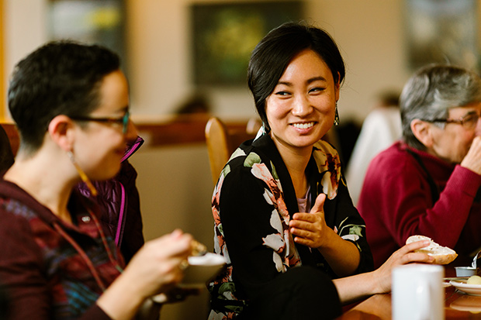
I was only praying to get through one day at a time; I only prayed for “daily bread.” A whole year later, Pope francis’ wors finally sunk in: “We find ourselves afraid and lost. Like the disciples in the Gospel, we wee caught off guard by an unexpected turbulent storm. We have realized that we are on the same boat, all of us fragile and disoriented, but at the same time important and needed, all of us called to row together, each of us in need of comforting the other.”

Gradually, the insight emerged that despite the disorientation, uncertainty also holds a special grace; in fact, it is an absolute requirement for us to grow from “I” to “we.” The uncertainty of this storm was overwhelming to any of us as individuals, but “navigable” as a community on the same boat with Jesus.

30 minutes of silence

We welcome one another’s reflections and prayers.

Closing: Dear God, may we never forget how much we need each other. After all, we are connected through your creation. Let us not be afraid to talk, to laugh, to cry, and to share stories and our lives with each other. Amen.

Or: Come, Holy Spirit. Fill the hearts of your faithful and kindle in us the fire of your love. Send forth your Spirit and we shall be created, and You shall renew the face of Earth. Amen.

Settling in: modified from Sacred Space, a website of the Irish Jesuits

Reading: from the Winter 2022 Occasional Papers of the Leadership Conference of Women Religious, on the theme “The Unknown: A Place of Potential and Possibility.” This excerpt is from the article whose title is cited above, in which Sister Annmarie Sanders interviews four younger women religious: Felician Sister Grace Marie Del Priore, Humility of Mary Sister Ellis McCulloh, Marianist Sister Nicole Trahan, and Jane Aseltytine, a Sister of the Immaculate Heart of Mary of Monroe, Michigan.
Image: “Nuns and Nones brings together religiously unaffiliated young adults and Catholic sisters” - https://faithandleadership.com/nuns-nones-brings-together-religiously-unaffiliated-young-adults-and-catholic-sisters
First Closing prayer option: Maria Shriver’s Sunday Paper https://www.mariashriversundaypaper.com/

