Solidarity with Sisters’ Communal Contemplative Prayer – Sept. 1-2, 2020

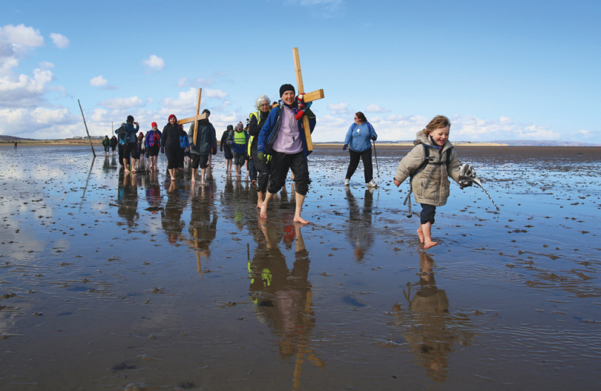
GATHERING

O God who creates and who gives breath,
be with us now as we come to you

with the great longings of our world

and of our selves.

We come together

trusting that the Spirit will be at work in us.

Help us to let go and to let come.

Help us to live the questions

and to move with you, in you, and toward you,

ever open to what is waiting to be born.

BEING HERE: Come as you are, in divine presence…

We have time here to let God’s presence into our awareness. How is God with you right now?... How is God greeting you as you choose to spend time here?... By what name are you greeting God?... Speak that name in your heart as you breathe in and out…. Let other things fall away and just feel God’s greeting to you and your greeting of God…. Let your breath slow and deepen… and feel your breath becoming one with God’s breath…. Let God’s breath carry you into 10 minutes of silence.

(10 minutes of silence)

AWARENESS:

To invite us to walk with God, we have the above image of carrying the cross, from our Sunday communal prayer that Mary Ott planned – and also a reading from Rilke’s Book of Hours: Love Poems to God, translated by Anita Barrows and Joanna Macy:

God speaks to each of us as he makes us,
then walks with us silently out of the night.

These are the words we dimly hear:

You, sent out beyond your recall,
go to the limits of your longing.
Embody me.

Flare up like flame
and make big shadows I can move in.

Let everything happen to you: beauty and terror.
Just keep going. No feeling is final.
Don’t let yourself lose me.

Nearby is the country they call life.
You will know it by its seriousness.

Give me your hand.

Let’s us give God our hands as we enter 20 minutes of silence.

(20 minutes of silence)

INTENTION -- Let’s invite each other to share the prayers that arise in us now.

(Shared prayers – “Holy One, hear our prayer.”)

O God, give us the courage to risk giving our hand to God and taking the path that opens. We ask this in solidarity with the Leadership Conference of Women Religious, for whom this is their life quest. For this we pray. Holy One, hear our prayer.

CLOSING

O Great Love, we place all of our prayers, those spoken and those unspoken, into your care, and we entrust the outcome to you. We are grateful that we walk with you and with each other, one step at a time. We pray together for light for our next step: Come, Holy Spirit. Fill the hearts of your faithful and kindle in us the fire of your love. Send forth your Spirit and we shall be created, and you shall renew the face of the earth. Amen.

SIGN OF PEACE

