Solidarity with Sisters’ Communal Contemplative Prayer – Oct. 13-14, 2020

GATHERING
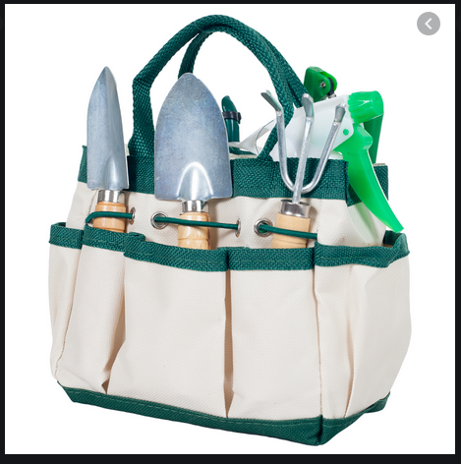
Loving God, we come here now to know you
alive in us.
Help us to let go and to let come.
Help us to live the questions.

Help us to settle into your presence with quiet openness.

Feel the comfort of your chair and relax into it… and relax into God’s love for you. Let your breath deepen and quiet. Notice your body and any tension you may be carrying. Releasing tension, you may want to tighten as you inhale and relax as you exhale—your head and jaw and neck, shoulders arms and hands, stomach, hips, legs and feet. If distractions come, let them slide away. Notice your breath. Take a deep breath, hold for a count of three, and very slowly exhale. Again. Feel your chest and stomach rise and fall as you gently breathe… Know the Spirit is moving in you gently and easily. Again, take 3 gentle breaths. One to be here… one to be together….and one to carry you into 10 minutes of silence in God.

(10 minutes of silence)

Here is a reflection by Sister Ilia Delio, who quotes from Rabbi Rami Shapiro. Let’s listen for where God speaks to us now, and take those words into 20 minutes of silence in the Spirit.

The question of heaven is not one of worthiness before God
but accepting God’s invitation for life:
“I have set before you life and death, choose life” (Deuteronomy 30:19). . . .

Christian life requires a conscious decision to focus on the central values of the gospel
and to dispense with all other things.
Without the choice for a new level of consciousness, there can be no new reality or reign of God.

Rabbi Shapiro writes, “I made the choice for heaven and, having done so,
I went in search of tools for living it.”
He asks:
Will you engage this moment with kindness or with cruelty, with love or with fear,
with generosity or scarcity, with a joyous heart or an embittered one?
This is your choice and no one can make it for you.
If you choose kindness, love, generosity, and joy,
then you will discover in that choice
the Kingdom of God, heaven, nirvana, this-worldly salvation.
If you choose cruelty, fear, scarcity, and bitterness,
then you will discover in that choice
the hellish states of which so many religions speak.
These are not ontological realities tucked away somewhere in space—
these are existential realities playing out in your own mind.
Heaven and hell are both inside of you.
It is your choice that determines just where you will reside.

(20 minutes of silence)

PRAYERS

Let’s come back together… Let us take a moment to let our experience in silence take a shape we can hold onto….. Let us invite each other to share the prayers that arise in us now.

(Shared prayers – “Holy One, hear our prayer.”)

O you who love us, help us to walk with Catholic sisters and the Leadership Conference of Women Religious, giving and receiving strength to choose life. Help us, together, to live in your reign of love and to learn the tools needed to help it grow. For this we pray. Holy One, hear our prayer.

CLOSING

O Great Love, we place all of our prayers, those spoken and those unspoken, into your care. We will all we can to live our prayers And we entrust the outcome to you. And so together we pray: Come, Holy Spirit. fill the hearts of your faithful and kindle in us the fire of your love. Send forth your Spirit and we shall be created, and you shall renew the face of the earth. Amen.

SIGN OF PEACE

Source of the reflection – Richard Rohr at https://cac.org/choosing-heaven-2017-12-22/
Rabbi Rami Shapiro, The Sacred Art of Lovingkindness: Preparing to Practice (SkyLight Paths Publishing: 2006), xii.
Ilia Delio, Making All Things New: Catholicity, Cosmology, Consciousness (Orbis Books: 2015), 96-97, 158-159.

