Solidarity with Sisters Communal Contemplative Prayer – June 30-July 1

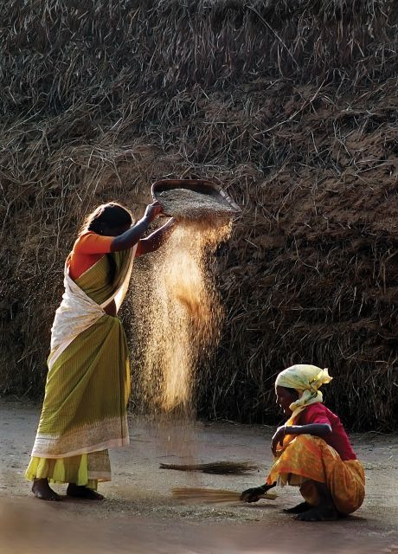
GATHERING
O God who creates and who gives breath,
be with us now as we come to you

with the great longings of our world

and of our selves.

We come together

trusting that the Spirit will be at work in us.

Help us to let go and to let come.

Help us to live the questions

and to move with you, in you, and toward you,

ever open to what is waiting to be born in us.

BEING HERE: Come as you are, in divine presence…

We are moving from getting here to being here. Let your body relax, feeling all the places it is supported. Let your breath slow and deepen. Exhale and release tensions. Inhale and welcome God into you. I invite you to give 10 minutes of silence to knowing God loves you.

(10 minutes of silence)

AWARENESS

Let us listen to the poem “Loaves and Fishes” by Sister Simone Campbell, from the 2013 reflective journal of the Leadership Conference of Women Religious:

I always joked that the miracle of
loaves and fish was sharing,
The women always knew this.
But in this moment of need and notoriety,
I ache, tremble, almost weep at
folks so hungry, malnourished, faced
with spiritual famine of epic proportions.
My heart aches with their need.
Apostle-like, I whine, what are we
among so many?
The consistent 2,000-year-old ever-new
response is this:
“Blessed and broken, you are enough.”
I savor the blessed, cower at the broken, and
pray to be enough.

You who love us, open our eyes to see you with us in these 20 minutes of silence.

(20 minutes of silence)

INTENTION

Let’s invite each other to share the prayers that arise in us now. Our response will be: You who love us, hear our prayer.

God among us, bless us in our brokenness, and make us your bread in this time of spiritual famine. In your grace, let us be enough, in companionship with the Leadership Conference of Women Religious and Catholic sisters. For this we pray. You who love us, hear our prayer.

(Shared prayers)
CLOSING

We place all of our prayers, those spoken and those unspoken, into your loving care, and we entrust the outcome to you. As we do, we use the words of Sister Pat Farrell. “There is so much more going on within and around us than we will ever be able to perceive. The unseen movement of Love is creatively holding everything together in ways infinitely beyond what we could ask or imagine.” We ask the Spirit to “open space in us to flow with what we cannot see, with what is beyond us. Yet the path remains always a walk in the dark. We walk it together, summoning one another to deepening faith in the invisible energy of Love that surrounds and carries us.”
And so together we pray: Come, Holy Spirit. Fill the hearts of your faithful and kindle in us the fire of your love. Send forth your Spirit and we shall be created, and you shall renew the face of the earth. Amen.

SIGN OF PEACE

