Solidarity with Sisters’ Communal Contemplative Prayer, Dates, 20xx

Gathering - Most gracious Love, we gladly come to your endless embrace. We are here (this evening) (this afternoon) to attune to your movement, so that our growth may always be in you.

So let us settle into your presence, Beloved One.
May I quiet my words and listen…. May I calm my thoughts and be….
May I soften my heart and open…. May I still my soul and receive….
(Pause) Our breath says we are here…. We are together…. we are in God.

A poem titled “Trasna,” which means Crossing, by Sister Raphael Considine

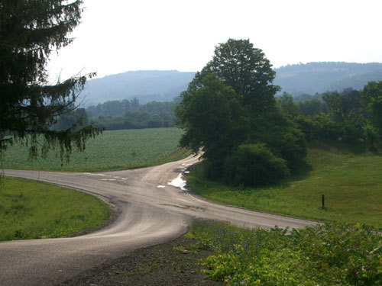
The pilgrims paused on the ancient stones
In the mountain gap.
Behind them stretched the roadway they had traveled .
Ahead, mist hid the track.
Unspoken the question hovered:
Why go on? Is life not short enough?
Why seek to pierce its mystery?
Why venture further on strange paths, risking all'
Surely that is a gamble for fools - or lovers.
Why not return quietly to the known road?
Why be a pilgrim still?
A voice they knew called to them, saying:
This is Trasna, the crossing place.
Choose! Go back if you must,
You will find your way easily by yesterday’s fires,
there may be life in the embers yet.
If that is not your deep desire,
Stand still. Lay down your load.
Take your life firmly in your two hands,
(Gently… you are trusted with something precious)
While you search your heart’s yearnings:
What am I seeking? What is my quest?
When your star rises deep within,
Trust yourself to its leading.
You will have the light for first steps.
This is Trasna, the crossing place.
Choose!
This is Trasna, the crossing place
Come !

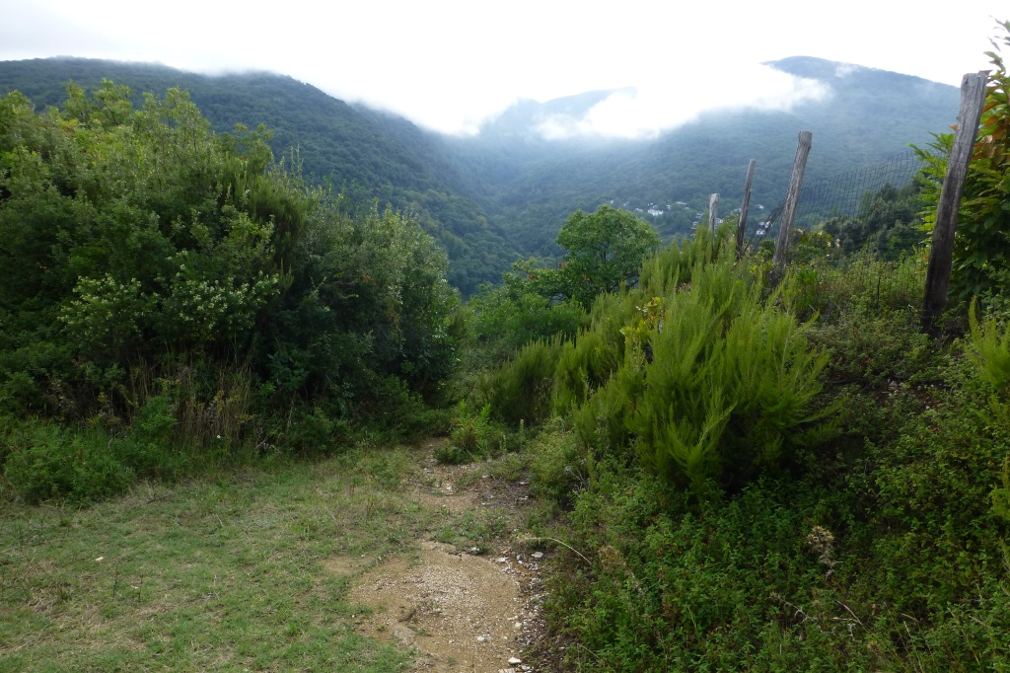

(30 minutes of silence)

(Sharing, if you would like)

Closing – Holy One, step by step may our journeys bring us ever deeper into your Divine delight, in solidarity with one another and with women religious. We give you this prayer and all our prayers, spoken and unspoken, entrusting the outcomes to you. “Make us now your living sign. Recreate us for your purpose in this place and in this time.” Amen.

Sr. Raphael Considine is a member of the Sisters of the Presentation of the Blessed Virgin Mary. Their many ministries with God’s people focus on especially poor women and children.

Second image from https://sophiawakens.com/2021/08/07/trasna-the-crossing-place/

