We gather in solidarity with women religious for
Communal Contemplative Prayer – Date, 20xx

Settle into the immense Love in which we live and move and have our being....
As I sit here, the beating of my heart,
the ebb and flow of my breathing, the movements of my mind
are all signs of God's ongoing creation of me.
I pause for a moment, and become aware
of this presence of God within me.
Notice if some words or images here lead you to rest in God. Follow them, or
just follow the Spirit.
Legacies, Alliances, and Building a New World – excerpts from
the Summer 2020 Occasional Papers of the Leadership Conference of Women Religious:

Where will we place our limited time, passion, and attentiveness so that it speaks clearly of a legacy? How might we most fully serve as caretakers of a people we will never meet, as lovers of a world we will not live to see?
(CK, IHM)

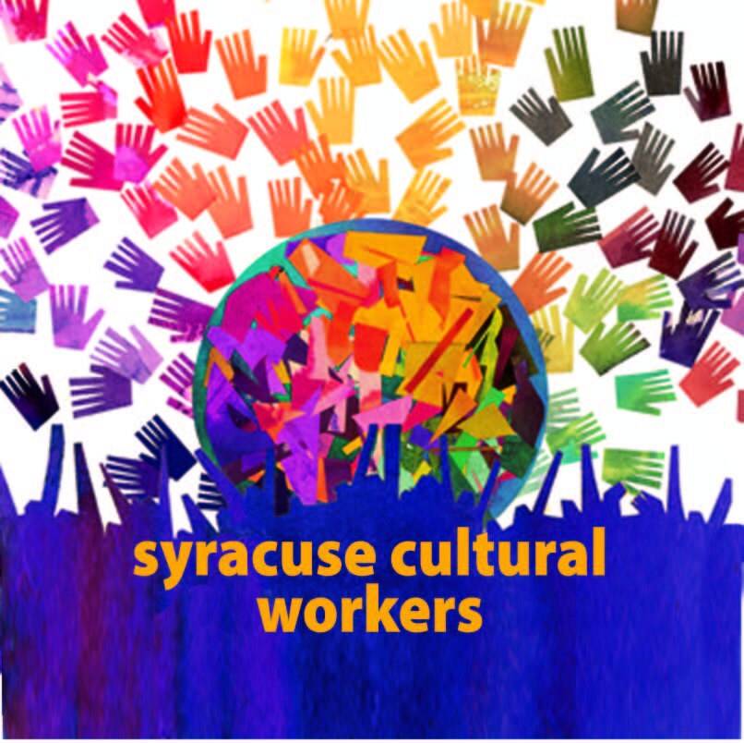
If we have been accustomed to being in charge, joining in alliances or partnerships may bring with it a reality that we will not be leading these groups or movements; often, we will be joining initiatives underway. Consequently, these groups may be moving in directions and with approaches with which we are unfamiliar or uncomfortable. This may lead to a sense of loss of control and influence. Yet, with aging…, new alliances, partnerships, and technological tools will be a unique opportunity for [us] to be even more effective in the 21st century in carrying out our mission. National and global networks linking like-minded partners may be a key part of that vision. Unprecedented times call for large social movements, partnerships, and collaborations in order to achieve greater impact. The gathering of diverse talent from a range of age groups and with racial and ethnic diversity can bring wider connections and broader influence to effectively bring about a more just and compassionate world. (KP, OP)

30 minutes of silence

We welcome one another’s reflections and prayers.

Closing: Dear God, may we never forget how much we need each other. After all, we are connected through your creation. Let us not be afraid to talk, to laugh, to cry, and to share stories and our lives with each other. Amen.

Or: Come, Holy Spirit. Fill the hearts of your faithful and kindle in us the fire of your love. Send forth your Spirit and we shall be created, and You shall renew the face of Earth. Amen.

Settling in: modified from Sacred Space, a website of the Irish Jesuits

Reflection includes excerpts from essays by Sister Chris Koellhoffer, IHM, and Sister Kathleen Popko, SP, in the Winter 2020 Occasional Papers of the Leadership /Conference of Women Religious.

The image is a logo of Syracuse Cultural Workers, a cooperative that makes and sells wonderful art and other materials - https://www.syracuseculturalworkers.com/?gclid=Cj0KCQiAnsqdBhCGARIsAAyjYjSnTFu6s51XwvktEITHH-jDgftuLyUOhdQ1YPncZ2fBFGtkDhQQEz8aAv54EALw_wcB

First Closing prayer option: Maria Shriver’s Sunday Paper https://www.mariashriversundaypaper.com/

