We gather in solidarity with women religious for
Communal Contemplative Prayer – Date, 202x

Settle into the immense Love in which we live and move and have our being....
As I sit here, the beating of my heart,
the ebb and flow of my breathing, the movements of my mind
are all signs of God's ongoing creation of me.
I pause for a moment, and become aware
of this presence of God within me….
Notice if something here leads you to the Holy One. Follow that path, or
just follow the Spirit.
“Integrating Our Ways of Knowing” in difficult times
Excerpt 2, by Sister Teresa Maya

We began to realize that we had an asset for facing the uncertainty; we are an intercultural community. How we “know” is influenced by our culture.
When I ‘know” in English, I need facts, predictions, certainty. To know in English is to saber – to understand. But understanding has been hard to come by. I realized it was time for us to know in Spanish – conocer – the knowing that happens in our hearts. This kind of knowing that comes via intuition and communion provides a certainty that no matter what, we will overcome.

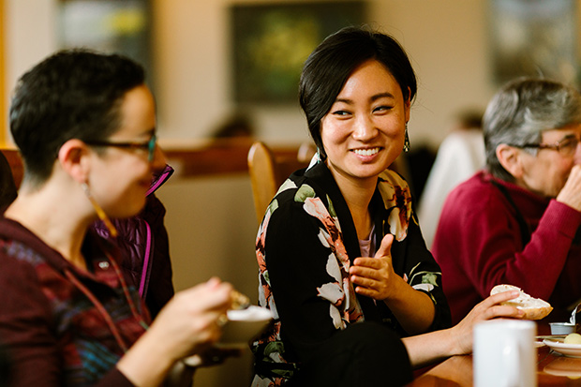
Our community decided we must focus on the question: How do we steward our community back to hope? We knew that knowing in English (saber) would not get us anywhere; this time, we needed to know in Spanish. We wondered: Could it be time to reconocer (know again and come to a new understanding of) who we are as a community?

Our conversations began several months ago. We were able to recognize one another again. We are coming together, finding meaning, returning to what is essential, discovering together why we are here, and deepening the “why” of our lives. This reconocer could not happen individually – reconocer is a communal process, a process of encuentro.

We needed the grace of the uncertainty to reconocer (recognize) the essential! Only a “we” can live with uncertainty.

30 minutes of silence

We welcome one another’s reflections and prayers.

Closing: Dear God, may we never forget how much we need each other. After all, we are connected through your creation. Let us not be afraid to talk, to laugh, to cry, and to share stories and our lives with each other. Amen.

Or: Come, Holy Spirit. Fill the hearts of your faithful and kindle in us the fire of your love. Send forth your Spirit and we shall be created, and You shall renew the face of Earth. Amen.

Settling in: modified from Sacred Space, a website of the Irish Jesuits

Reading: from the Winter 2022 Occasional Papers of the Leadership Conference of Women Religious, on the theme “The Unknown: A Place of Potential and Possibility.” This excerpt is from the article whose title is cited above, in which Sister Annmarie Sanders interviews four younger women religious: Felician Sister Grace Marie Del Priore, Humility of Mary Sister Ellis McCulloh, Marianist Sister Nicole Trahan, and Jane Aseltytine, a Sister of the Immaculate Heart of Mary of Monroe, Michigan.
Image: “Nuns and Nones brings together religiously unaffiliated young adults and Catholic sisters” - https://faithandleadership.com/nuns-nones-brings-together-religiously-unaffiliated-young-adults-and-catholic-sisters
First Closing prayer option: Maria Shriver’s Sunday Paper https://www.mariashriversundaypaper.com/

