Solidarity with Sisters Communal Prayer for Sunday, August 9, 2020
I go before you always.
Deuteronomy 31:8
TECHNICAL CHECK-IN (Betty)
I’m Betty Thompson and I welcome you here on behalf of Solidarity with Sisters.
- We sent the files of readings, responses, and lyrics.
- Camera: turn on if you want. Gallery view option.
- Mute/Unmute: know how? Needed even during singing.
- I will now mute everybody. Unmute to speak.
Now let’s put technical things aside.

WELCOME (Betty)
Welcome, everyone!
- Introductions – people who haven’t been here before?
- Anne & Bill had the pleasure of preparing today’s communal prayer.
- Thanks to Reggie Ott for leading us in music.
- Thanks to the people who will be reading and leading us in prayer during our prayer today – Lynn Bufka, Donna & Bill Ellerman, Mary Ott, and Suzie & Jim DeQuattro. If you’d like to read on future Sundays, please get in touch.

SETTLING IN (Anne Regan)

We are here to let God transform us. In the words of our friend, Sister Marie McCarthy, let’s open ourselves as fully as we can to the presence and action of God’s love and spirit within and among us. Let’s just take a few moments of quiet to ground ourselves, bring ourselves to be here and to breathe in God’s love for each and for all, and breath that love back out again into our troubled and wounded world.

Now Reggie Ott will lead us into our celebration.

OPENING – HERE I AM, LORD by John Michael Talbot (Reggie Ott)
I, the Lord of sea and sky
I have heard my people cry
All who dwell in dark and sin
My hand will save
I who made the stars of night
I will make their darkness bright
Who will bear my light to them?
Whom shall I send?
Here I am, Lord
Is it I, Lord?
I have heard You calling in the night
I will go, Lord
If You lead me
I will hold Your people in my heart
I, the Lord of wind and flame
I will tend the poor and lame
I will set a feast for them
My hand will save
Finest bread I will provide
'Til their hearts be satisfied
I will give my life to them
Whom shall I send?
Here I am, Lord
Is it I, Lord?
I have heard You calling in the night
I will go, Lord
If You lead me
I will hold Your people in my heart
I will hold Your people in my heart

GREETING (Bill)

Beloved community, rejoice! The Spirit of Christ is among us! Alleluia!
All: And all God’s people reply: Amen! Alleluia!
CALL TO WORSHIP (Bill)
We come together today because it is with each other that we experience ourselves as the people of God and the body of Christ. As Monsignor Lyon used to tell us, “We gather to celebrate the great fact that God is in love with us.”
We come expecting something to happen this morning. We believe that whenever two or three gather in the name of Jesus, then Jesus is right here. So we are confident that in this next hour God will act in us and give us insight about how to go forth and make the Gospel visible in more ways and in more places. We say yes to this call and we seek light for our next step. And now let us pray.

GATHERING PRAYER (Anne)
O God who creates and who gives breath,
be with us now as we come to you
with the great longings of our world
and of ourselves.
We come together
trusting that the Spirit will be at work in us.
Help us to let go and to let come.
Help us to live the questions
and to move with you, in you, and toward you,
ever open to what is waiting to be born in us.
Amen.

INTRODUCTION TO THEME (Anne)
We are living in times of unanticipated chaos, where old forms are giving way and the new forms are not yet clear. Our faith tells us that in times of chaos, divine presence draws near.
In today’s readings, we are invited to consider the ways in which God’s presence becomes known. In Kings, we look at the prophet Elijah hiding in a cave on Mount Sinai, having had enough of having his hopes dashed for how God’s work should be done - in his humble opinion. Queen Jezebel was slaughtering the Lord’s prophets, so Elijah challenged her to have four hundred and fifty of her own prophets call upon Ba’al to consume an offering. When they failed, Elijah called upon the God of Israel, and immediately, Elijah’s offering was devoured. Elijah then seized the prophets of Ba’al, and slaughtered them. Elijah thought this demonstration would certainly result in the conversion of Queen Jezebel and King Ahab.
Instead, Jezebel told Elijah he will meet the same end as her prophets. Elijah fled for his life, and we find him full of despair, hiding in a cave.
In Matthew, we pick up with the disciples right after the loaves and the fishes of last week, and Jesus and Peter walk on the water. Jewish people of the time would hear the echoes of Psalms where God “stretches forth thy hand from on high and rescues me and delivers me out of great waters.” The storm is a symbol of the presence of God. In moments of great need, we recognize the presence of the Lord. Both readings inform us about what becomes possible when God’s presence makes itself known.
In our third reflection, we will consider what Meg Wheatley and John Lewis suggest about the connection between the still quiet voice, being led to the edge, and living the gospel.
After each reading, we will offer questions before we pause for silent reflection. Don’t feel you have to answer all questions. To stay with only one of them might lead you into a deeper place.

Now Donna Ellerman will read from KINGS. Then Jim De Quattro will offer questions for our reflection.

READING 1: 1 Kings 19:9-15a (Donna)
At the mountain of God, Horeb, Elijah came to a cave where he took shelter. [But the word of the LORD came to him: Why are you here, Elijah?
He answered: “I have been most zealous for the LORD, the God of hosts, but the Israelites have forsaken your covenant. They have destroyed your altars and murdered your prophets by the sword. I alone remain, and they seek to take my life.”]
Then the LORD said to him,
“Go outside and stand on the mountain before the LORD;
the LORD will be passing by.”
A strong and heavy wind was rending the mountains
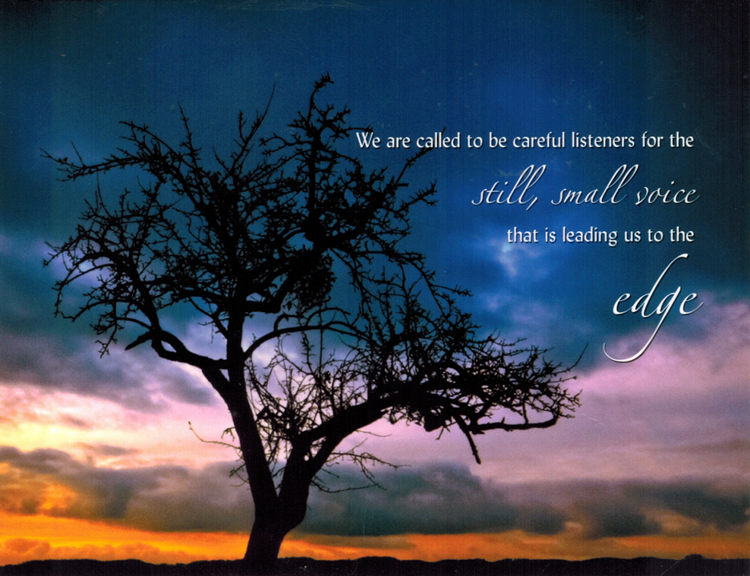
and crushing rocks before the LORD—
but the LORD was not in the wind.
After the wind there was an earthquake—
but the LORD was not in the earthquake.
After the earthquake there was fire—
but the LORD was not in the fire.
After the fire there was a tiny whispering sound.
When he heard this,
Elijah hid his face in his cloak
and went and stood at the entrance of the cave.
[A voice said to him, Why are you here, Elijah?
He replied, “I have been most zealous for the LORD, the God of hosts, but the Israelites have forsaken your covenant. They have destroyed your altars and murdered your prophets by the sword. I alone remain, and they seek to take my life.”
The Lord said to him: Go back! Take the desert road to Damascus.]
REFLECTION QUESTIONS (Jim De Quattro)
What helps you hear the still, small voice?
What sends you to a cave to hide out, and, should God inquire, what is your lament?
When have you felt called to go back, and “take the desert road” to a situation you wanted to leave behind?
SILENCE (Sound a chime after 2 minutes.) (Anne)
Anne: Now Bill Ellerman will read from the 14th chapter of Matthew.
READING 2: Matthew 14:22-33 (Bill E.)
After he had fed the people, Jesus made the disciples get into a boat
and precede him to the other side,
while he dismissed the crowds.
After doing so, he went up on the mountain by himself to pray.
When it was evening he was there alone.
Meanwhile the boat, already a few miles offshore,
was being tossed about by the waves, for the wind was against it.
During the fourth watch of the night,
he came toward them walking on the sea.
When the disciples saw him walking on the sea they were terrified.
“It is a ghost,” they said, and they cried out in fear.
At once Jesus spoke to them, “Take courage, it is I; do not be afraid.”
Peter said to him in reply,
“Lord, if it is you, command me to come to you on the water.”
He said, “Come.”
Peter got out of the boat and began to walk on the water toward Jesus.
But when he saw how strong the wind was he became frightened;
and, beginning to sink, he cried out, “Lord, save me!”
Immediately Jesus stretched out his hand and caught Peter,
and said to him, “O you of little faith, why did you doubt?”
After they got into the boat, the wind died down.
Those who were in the boat did him homage, saying,
“Truly, you are the Son of God.”

REFLECTION QUESTIONS (Jim)

When do you cry out "Lord, save me"?
In what way do you hear Jesus say "take heart, it is I; have no fear?"

When do you find yourself stepping out of the boat into the chaos?

SILENCE (Sound a chime after 2 minutes.) (Anne)

Anne: Now Betty Thompson and Bill Fanelli will read a reflection on the themes of these scriptures.

REFLECTION: Excerpted from Meg Wheatley and John Lewis (Betty & Bill)
Betty: Addressing the Leadership Conference of Women Religious at the 2016 Assembly, Dr. Margaret Wheatley gave a talk titled “Finding Ground in the Age of Groundlessness.” She said:
We are called to be careful listeners to the still, small voice that is leading us to the edge. A long time ago I was told that the voice of God, the voice of the Holy Spirit, speaks as loudly as we are willing to listen, and that has been a great source of guidance to me. If I couldn’t hear the voice of Spirit, I knew that it was my problem. It wasn’t that the Holy Spirit had turned away from me, it’s just that I had moved in the position of thinking, “I know what to do, I’m in charge here. Thank you, I got the inspiration now. I’m just running off with it.”
But this still, small voice is not small, and I think part of our resistance, certainly my resistance, was where it leads us. ... When we listen to Spirit, when we really listen and tune in, we are led to the edge. Not a comfortable place to be. So there is enormous risk involved in being willing to be used by God. There is enormous possibility, but there is also enormous risk.
Bill: Over the last few weeks, we have had the opportunity to reflect on the life and faith of the Honorable John Lewis. His life is witness to what it means to be led to the edge and be willing to return, over and over again. In his actions, we see the embodiment of the African proverb “When you pray, move your feet.” John Lewis described his experience in these words
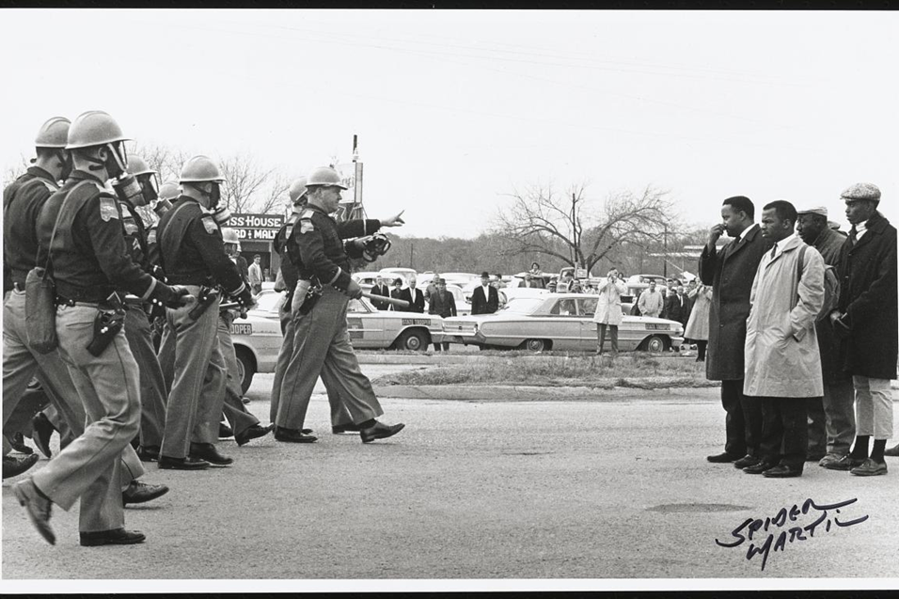
When we were sitting in, it was love in action.
When we went on the freedom ride, it was love in action.
The march from Selma to Montgomery was love in action.
We do it not simply because it’s the right thing to do, but it’s love in action. That we love our country, we love a democratic society, and so we have to move our feet.
Rep. John Lewis
REFLECTION QUESTIONS (Jim)

What is the difference between what you think God wants you to do and what comes to you in the silence?

What risks does heeding the deep still voice bring up?

SILENCE (Sound a chime after 2 minutes.) (Anne)

Now Mary Ott will lead us in sharing.
SHARING (Mary)
We invite you to briefly share what emerged in your heart this morning as you listened and as you reflected on these readings. When we speak of our own personal feelings, we glimpse the many ways God is among us.
If you would like to speak, please unmute yourself, and mute yourself again afterwards. If two people speak at once, we can take turns.
Who would like to begin our sharing?
(Sharing)
Thank you.
Now Lynn will lead us in prayer.

COMMUNITY PRAYERS (Lynn Bufka)
We have just listened to God’s word – in scripture, in everyone’s reflections, and in our hearts and minds. Elijah teaches us to listen for the still, small voice. Let’s pause in silence so we can each answer this question: This morning, what is God’s word here to do in me? What has the word of God invited me to become or to do?
[Pause….]
God within us, thank you for the awareness you give us today. Each day this week, we ask you to show us how to make your word into our reality.
Now, as we offer our prayers, our response will be: Holy One, hear our prayer.
God among us, give us the audacity to fully accept your kindness, let go of our own expectations, and risk being careful listeners for the still small voice that is leading us to the edge. For this we pray. Holy One, hear our prayer.
God in all things, we thank you for the endless ways you are present in this pivotal time. For this we pray. Holy One, hear our prayer.
God of love, pour your abundance into the Leadership Conference of Women Religious as they gather on August 12th through 15th in their annual Assembly. For this we pray. Holy One, hear our prayer.
Along with LCWR, we pray for the ability to see beyond the world’s present difficulties and to be the embodiment of the Beloved Community. Holy One, hear our prayer.
Now let’s remember the feelings and prayers that arose in us as we shared reflections, and also the prayers we carry with us. [Pause.]
Now, for what else shall we pray? Please unmute yourself as you speak. Please end your petition with “for this we pray.”
(People speak.)
Thank you.
We place all of our prayers, those spoken and those unspoken, into your loving care, and we entrust the outcome to you.
Help us to hear over the howling wind of bad news that drowns out your voice.
Give us ears and hearts attentive to your voice when you say to us, ”Do not fear, it is I.”
Amen.

OFFERING/STEWARDSHIP (Bill)
In response to the grace and goodness of our God, we are mindful of the great blessings we enjoy. We desire to see these as abundance to be shared with a broken world. Let us take time to name within ourselves something we will offer to others in recognition of all that we have received. [Pause.]
In thanksgiving for the presence and power of Jesus Christ, and in unity with the Holy Spirit, let us pray. God of abundance, we commit to sharing our time, talents, and treasures so that we may be a light and a witness to the transforming love of Jesus Christ. Amen.

CELEBRATION OF COMMUNION (Suzie)
O Great Love, we are humbled and emboldened
to know that you trust us to be your body in this world.
We are part of that body as we let go of all that separates us from you,
and as we embrace one another and your entire creation with merciful love.
We give you thanks for your presence in us. [Pause.]
We remember the night before Jesus died.
At dinner with friends, Jesus knew all that would soon be asked of them,
and, loving them to the end, Jesus showed them how to care for each other
as they went out into the world.
First Jesus washed their feet.
Then he looked at what was in front of them, the bread and the cup,
gifts of the earth and work of human hands, and blessed them.
So let us, too, invite God right now into what is front and center in our lives
knowing that God will indeed enter what we offer – and bless it. [Pause.]
Let us invite God into ourselves so that we become God’s living presence. [Pause.]
Holy One, you transform us as you nourish us here.
May we nourish others with your love.
Amen.

OUR FATHER (Bill)
Now let us pray in harmony with all Christians throughout the world in the words that Jesus gave us:
Our Father, who art in heaven, hallowed be thy name.
Thy kingdom come. Thy will be done on earth as it is in heaven.
Give us this day our daily bread
and forgive us our trespasses as we forgive those who trespass against us,
and lead us not into temptation, but deliver us from evil
for the kingdom, the power, and the glory are yours, now and forever. Amen.

FINAL BLESSING (Anne)

Broken, we have gathered. Nourished, we reach out.
Now let us now go forth in peace:
in communion with each other
and offering communion to a hungry world. Amen.

Now Reggie will lead us in “Be not afraid”:

CLOSING: BE NOT AFRAID by St. Louis Jesuits (Reggie Ott)

You shall cross the barren desert
But you shall not die of thirst
You shall wander far in safety
Though you do not know the way
You shall speak your words to foreign men
And they will understand
You shall see the face of God and live
Be not afraid
I go before you always
Come, follow me and I will give you rest
If you pass through raging waters in the sea
You shall not drown
If you walk amid the burning flames
You shall not be harmed
If you stand before the power of hell
And death is at your side
Know that I am with you through it all
Be not afraid
I go before you always
Come, follow me and I will give you rest

Sources for insights and excerpts used in the Introduction to Theme, Reflection Questions, Reflection, and Prayers of the Faithful:

Sr. Mary M. McGlone, resources for the 19th Sunday in Ordinary Time, 2020
(https://www.ncronline.org/sunday-resource/aug-9-2020-nineteenth-sunday-ordinary-time)

