SOLIDARITY WITH SISTERS’ COMMUNAL PRAYER
16TH SUNDAY OF ORDINARY TIME
July 23, 2023
“Teasing our minds into new ways of thinking
about who God is and what God dreams for us.”

Please bring bread and wine/beverage.

HELLOs and then Zoom Host mutes everyone. (Betty Thompson)

WELCOME (Kathy Linabery)

Welcome, everyone!
- Norb Bufka, Lin Linabery, Deb Ballard and I prepared our communal prayer for today.
- Introduction - people who haven’t been here before?
- Thanks to the people who will be reading and leading us in prayer today: Maryann Dolan, Richard McGinnis, Peggy Thompson, Alicia Urban, Karen and Dan McCarthy, Kathy and Bill Cavanaugh, Ann Masters, and Sister Vera Ruotolo. We are always looking for new readers and grateful for your help. If you are available on August 20, please contact Terri Butel and for Aug. 27 the Cavanaughs. You can leave a message in chat or email the planners.
- We want to remind you that Betty and Suzie are taking a break so we will not be here on Zoom on July 30 and August 6. We will be back together again Aug. 13.

SETTLING IN (Deb Ballard)

Let yourself settle into the quiet center in yourself. Feel the breath moving in you… in and out… loosening you… making space inside you…. In and out…. God’s own breath entering you…. uniting you with all that breathes, all that is… opening you to the Spirit moving in you…. In us…. Here….
OPENING SONG: Seed Scattered and Sown Dan Feiten
https://www.youtube.com/watch?v=4HGiozLMJTk&t=18s&ab_channel=AgnesChoo

Seed, scattered and sown; wheat, gathered and grown;
Bread, broken and shared as one, the Living Bread of God.
Vine, fruit of the land; wine, work of our hands; one cup that is shared by all;
the Living Cup, the Living Bread of God.

Is not the bread we break a sharing in our Lord?
Is not the cup we bless, the blood of Christ outpoured? (Refrain)

As wheat upon the hill was gathered and was grown,
So may the church of God be gathered into one. (Refrain)

CALL TO WORSHIP/GATHERING PRAYER (Karen McCarthy)

Ordinary time is a season for us to recognize the ordinary, extraordinary sacraments around and in us. Ordinary time is when we take the gifts of Pentecost and turn them into active graces in ordinary situations.
We pray that we ourselves will be ordinary sacraments. May we be everyday signs of God’s presence and sources of grace. May we encourage, inspire, and challenge each other to imagine what none of us could conceive alone. May it be so.

INTRODUCTION TO THEME (Richard McGinnis)

We chose for our primary reading, this morning, the familiar Gospel parable of the wheat and the darnell. Darnell is a plant that resembles wheat but its seed is deadly if too many are eaten. Initially, it is important for us to reflect on what a parable is.

Bishop Ken Untener points out that a parable is not a moral teaching, but tells us something about God and therefore about ourselves.

In her book, The Seeds of Heaven, Barbara Brown Taylor writes: “The lovely thing about parables is that they rarely answer questions ….. They behave more like dreams or poems instead, delivering their meaning in images that talk more to our hearts than to our heads. Parables are mysterious …. they teach us something different every time we hear them.”

While Matthew has Jesus giving the disciples an explanation of this parable, we have left it out. Instead, we encourage you to reflect on the possibilities for you in your life. It will take patience, compassion, forgiveness and love to view ourselves as a mixture of weed and wheat.

Now Peggy Thompson will read a portion of Chapter 13 of Matthew’s Gospel. Dan McCarthy will offer questions that lead us into silence.

READING 1 (Peggy Thompson)

Jesus put another parable before them, 'The kingdom of heaven may be compared to a farmer who sowed good seed in a field.

While everybody was asleep an enemy came, sowed darnel all among the wheat, and made off. When the new wheat sprouted and ripened, the darnel appeared as well.

The owner's servants came and asked, "Sir, was it not good seed that you sowed in your field? If so, where does the darnel come from?"

"Some enemy has done this," the farmer answered. And the servants said, "Do you want us to go and weed it out?"

But the farmer said, "No, because when you weed out the darnel you might pull up the wheat with it.
Let them both grow till the harvest; and at harvest time I shall say to the reapers: First collect the darnel and tie it in bundles to be burnt, then gather the wheat into my barn."'

REFLECTIVE QUESTIONS 1 (Dan McCarthy)
(Pause after each question.)

- What is comfortable or uncomfortable to you about the image of God in this parable?

- What new understanding of yourself have you discovered in this parable?

- Where are you having a difficult time separating the good wheat in your life from the life-threatening darnell?

COMMUNAL SILENCE (Betty: Share slide with questions, time 2:00, chime.)
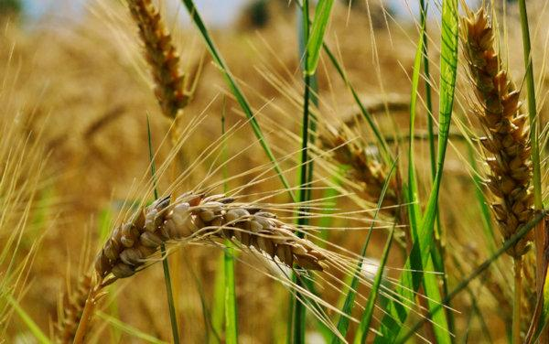
Betty: Mary Ann Dolan will now read from a homily given by Bishop Ken Untener in July 2002.
READING 2 (Maryann Dolan)
This Gospel set me thinking. Isn't that parable a bit far-fetched? After all, even a city slicker can tell the difference between weeds and wheat.
In the parable about the weeds and the wheat, there was a certain kind of plant in that part of the world that looked very much like wheat. The farmer is afraid that the workers will not always be able to distinguish between the wheat and the weeds.
So, what do we learn from this?
Many Scripture passages aren't trying to teach us how to behave. They teach us something about God, and we should simply catch hold of that and enjoy it. Instead of talking about our behavior, we should think about what God is like. The more we understand God, the more we understand ourselves, because we're made in the image and likeness of God. Then people can draw their own conclusions.
The parable in today's Gospel teaches us about God.
It occurred to me that we could catch the meaning of this Gospel parable by thinking about high school class reunions. Those of you who are old enough to have had twenty-five year reunions know how differently we look at some of our classmates after all that time. When we were in high school, our evaluation of some of our classmates was way wide of the mark. Our judgments were superficial ones - based on their athletic ability or their looks. We thought some were wheat and others were weeds.
But as the years went by we were able to see them in a different light. Some of the people we thought were weeds turned out to be fine people.
Actually, it's probably more likely that we're the ones who think we are a weed. We think of ourselves that way.
But God sees things differently. God is patient, kind, and loving like a grandparent. If you want to know what God is like, picture that farmer in the Gospel. The servants wanted to go and pull up the weeds, and the farmer says, "Well, let's not be too hasty, too quick to judge. Let's give it some time. We might pull out some wheat thinking it's a weed." That's God speaking. And it's a picture of God that Jesus himself gives us. And it's the way God treats us, because God loves us very, very much.
It's wonderful to have a God like that.
REFLECTIVE QUESTIONS 2 (Dan McCarthy)
(Pause after each question.)
- Looking back at how you have grown and changed in life, where are you grateful for God’s merciful patience and slowness to judge?

- When have you wanted to act quickly only to realize it is better to wait and not judge?

- How can you make this patient discernment part of your ordinary life?

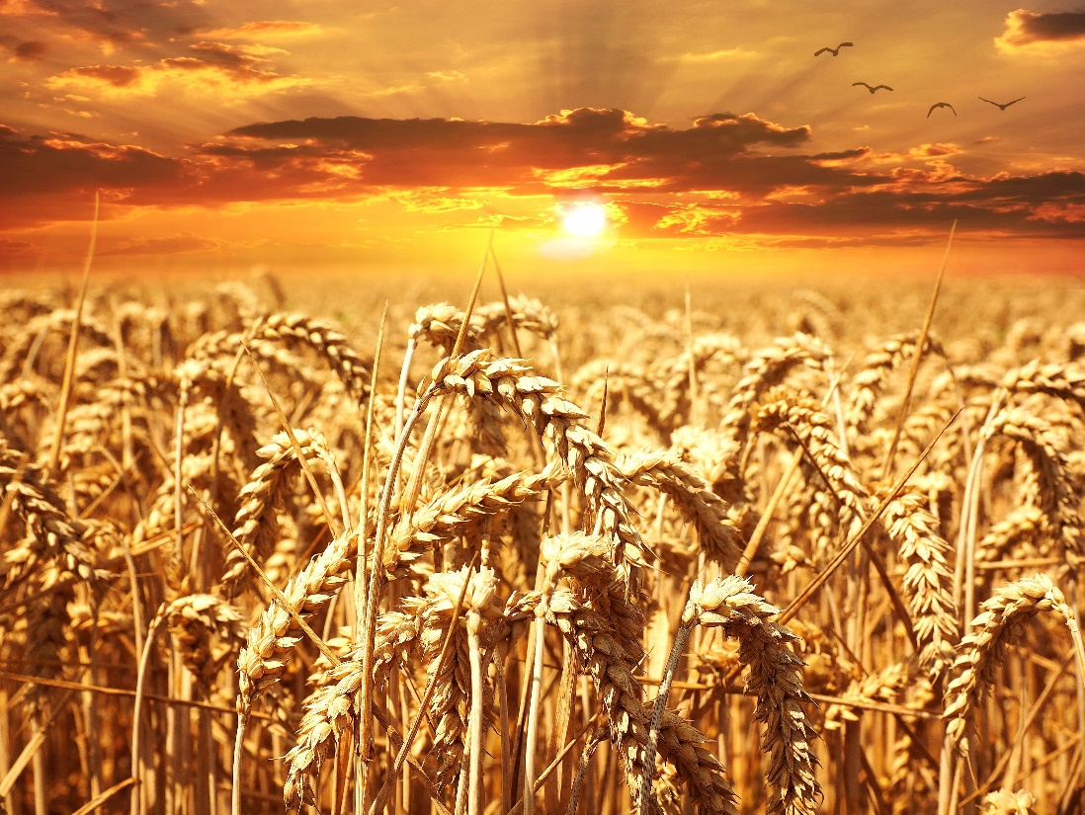

COMMUNAL SILENCE (Betty: Share slide with questions, time 2:00, chime.)
Betty: Kathy Linabery will read from Barbara Brown Taylor’s book: The Seeds of Heaven
READING 3 (Kathy Linabery)

Here is another parable of the wheat and the weeds. One afternoon in the middle of the growing season, a bunch of farmhands decided to surprise their boss and weed his favorite wheat field. No sooner had they begun to work, however, than they began to argue - first about which of the wheat-looking things were weeds and then about the rest of the weeds. Did the Queen Anne’s lace pose a real threat to the wheat, or could it stay for decoration? And the blackberries? They would be ripe in just a week or two, but they were, after all, weeds - or were they? And the honeysuckle - it seemed a shame to pull up anything that smelled so sweet.

About the time they had gotten around to debating the purple asters, the boss showed up and ordered them out of his field. Dejected, they did as they were told. Back at the barn he took their machetes away from them, poured them some lemonade, and made them sit down where they could watch the way the light moved across the field. At first, all they could see were the weeds and what a messy field it was, what a discredit to them and their profession, but as the summer wore on they marveled at the profusion of growth - tall wheat surrounded by tall goldenrod, ragweed, and brown-eyed Susans. The tares and the poison ivy flourished alongside the Cherokee roses and the milkweed, and it was a mess, but a glorious mess, and when it had all blossomed and ripened and gone to seed, the reapers came.

Carefully, gently, expertly, they gathered the wheat and made the rest into bricks for the oven where the bread was baked. And the fire that the weeds made was excellent, and the flour that the wheat made was excellent, and when the harvest was over the owner called them all together - the farmhands, the reapers, and all the neighbors - and broke bread with them, bread that was the final distillation of that whole messy, gorgeous, mixed-up field, and they all agreed that it was like no bread any of them had ever tasted before and that it was very, very good. Let those who have ears to hear, hear.

REFLECTIVE QUESTIONS 3 (Dan McCarthy)
(Pause after each question.)

- When have you judged something to be evil, only to find out that it has a good to offer if you think about it differently?

- What helps you to see everything as coming from God and having a purpose?

- When do you stop trying to fix things and simply look at what is, both wheat and weeds, with gentle eyes?
COMMUNAL SILENCE (Betty: Share slide with questions, time 2:00, chime.)

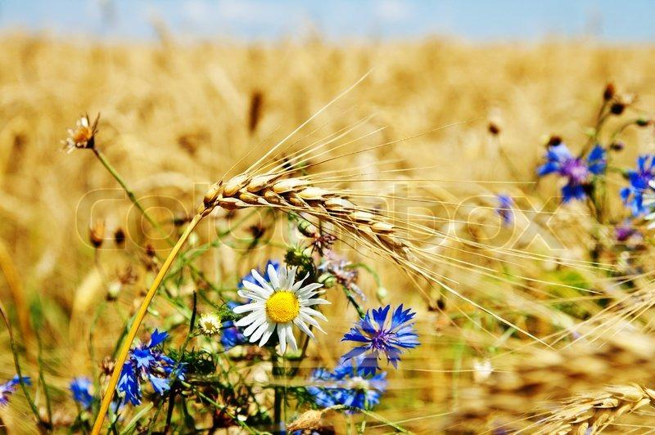
Betty: Alicia Urban will lead us in sharing our personal reflections.

SHARING (Alicia Urban)
Take a moment to look at all of us gathered here this morning, the community that we have come to know through words and silence. Each of you brings a unique glimpse of God in your words and your listening. We long to hear from everyone who wishes to share. And so, we invite you to share one thought or feeling from your reflections this morning. We ask that you allow a bridge of respectful silence after each speaker to receive the gift they offer – enough time to take two slow breaths.
So let’s begin in silence as we gather our reflections. [pause]

Now who would like to start our sharing?

[People share personal reflections. If there is extended silence during the sharing:] Is there anyone else who would like to share? [Pause for a slow, deep breath.]

[Stop after 20 minutes, but no later than 20 minutes after the hour]

Thank you to each of you who shared and to all who listened If there was not time for you to share or speak fully, we can continue after the final song as we often do, or send your reflection to Judy Sholes for our follow-up email.

Now let us turn to God in prayer.

PRAYERS OF THE COMMUNITY (Ann Masters)
Let’s pause to notice the prayers that arise in us now. (Pause) Our response will be: For this we pray: Merciful One, hear our prayer.
May our hearts and minds be open to a deeper understanding of God and the ways of God in our world. For this we pray: Merciful One, hear our prayer.
For the Leadership Conference of Women Religious, that their annual assembly on Aug. 8-11 will guide them to gently and clearly reflect and share the many ways God reveals God’s Self to all of us. For this we pray: Merciful One, hear our prayer.
That we recognize God in all our fellow human beings, even those we don’t like; in plants and animals, and even in the stones and other inanimate objects. For this we pray: Merciful One, hear our prayer.
For an end to the wars in Ukraine, Sudan, and other places through a recognition of God’s presence in all people. For this we pray: Merciful One, hear our prayer.

For what else shall we pray? Please unmute yourself to speak, and mute yourself afterwards.
[Shared prayers] Merciful One, hear our prayer.
Merciful One, we give you our prayers, spoken and unspoken, with trust in your love. Amen.
OFFERTORY (Lin Linabery)

Holy One, we offer you our ordinary selves, our talents, our resources. Take what we are and transform us into living sacraments that bring your grace into the world. We commit ourselves to be alert for the moments where we can be channels for your presence. We think ahead toward the coming week to notice specific opportunities that may arise. (Pause to think) We commit to let your Spirit act in us. May it be so.

CELEBRATION OF COMMUNION (Kathy Cavanaugh)

Gracious and Loving God:

We pray that our breaking of the bread and blessing of the wine this morning will put us in touch with the life, death, and resurrection of Jesus.

Jesus could not communicate all He wished to reveal on the night before his death so

HE BROKE BREAD AND BLESSED WINE
ASKING US TO REMEMBER IN THIS WAY.

As the Living Body of Christ, may we be energized by the Spirit, breaking bread
and sharing the cup in communion with our God and one another.

Now let us take and eat the bread and drink the wine. (Pause to do this.)

Let us invite God right now into what is front and center in our lives as we pray together:

Holy One, we entrust ourselves to you and to one another.
Make us your bread of abundance. Make us your wine of joy.
May we be caring people who wash feet and heal wounds,
and be poured out, a reason for others to celebrate!

Blessed be!

Bill Cavanaugh will lead us in the prayer of Jesus.

THE PRAYER OF JESUS (Bill Cavanaugh)

Heavenly Father, heavenly Mother,
Holy and blessed is your true name.
We pray for your reign of peace to come,
We pray that your good will be done,
Let heaven and earth become one.
Give us this day the bread we need,
Give it to those who have none.
Let forgiveness flow like a river between us,
From each one to each one.
Lead us to holy innocence
Beyond the evil of our days —
Come swiftly Mother, Father, come.
For yours is the power and the glory and the mercy:
Forever your name is All in One.

FINAL BLESSING (Sr. Vera Ruotolo)

In this century and in any century,
Our deepest hope, our most tender prayer,
Is that we learn to listen.
May we listen to one another in openness and mercy.
May we listen to plants and animals in wonder and respect.
May we listen to our own hearts in love and forgiveness.
May we listen to God in quietness and awe.
And in this listening,
Which is boundless in its beauty,
May we find the wisdom to cooperate
With a healing spirit, a divine spirit
Who beckons us into peace and community and creativity.
We do not ask for a perfect world.
But we do ask for a better world.
We ask for deep listening. Blessed be.

Final Song: Sing of the Lord’s Goodness

https://www.youtube.com/watch?v=wnx-wdIJvt4&ab_channel=jazzchurchuk

Sing of the Lord’s goodness, Father of all wisdom,
come to the Lord, bless God’s name.
Mercy you have shown us, your love is forever
faithful to the end of days.

Refrain:
Come then, all you nations, sing of your Lord’s goodness,
melodies of praise and thanks to God.
Ring out the Lord’s glory, praise God with your music,
worship the Lord, bless God’s name.

Praise God with your singing, praise God with the trumpet,
praise God with the lute and harp;
praise God with the cymbals, praise God with your dancing,
praise God till the end of days. Refrain

RESOURCES:

Bishop Untener’s Homilies
Visitation North Spirituality Center

The Seeds of Heaven: Sermons on the Gospel of Matthew
Barbara Brown Taylor

Lord’s Prayer: Father, Mother
Parker Palmer

