Solidarity with Sisters’ Communal Prayer
ascension

may 21, 2023

“And hidden down in the depths of ourselves is a union that’s already present, waiting to be realized, lived, and shared.” James Finley. “God Is the Ground of Our Being.” Richard Rohr’s Daily Meditation, April 24, 2023.

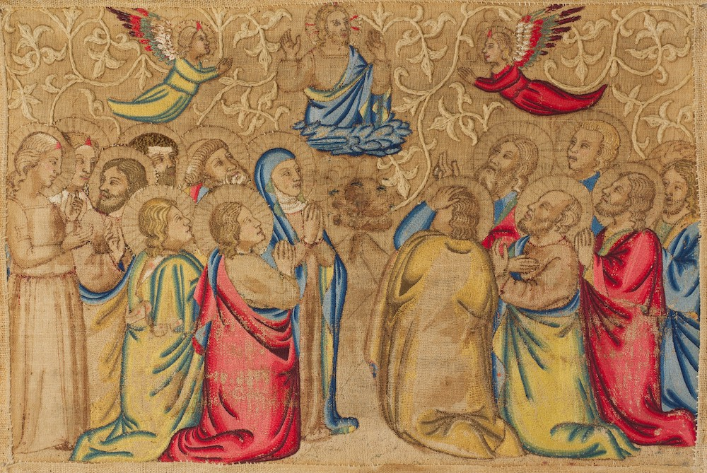
"The Ascension," 14th-century Italian embroidery (Metropolitan Museum of Art, The Cloisters Collection, 1960) https://www.ncronline.org/files/Ascension%20c_0.jpg

HELLOs, then Zoom host mutes everyone. (Betty Thompson)

WELCOME (Richard McGinnis)
Welcome, everyone!
- I am Richard McGinnis and I prepared our prayer for today.
- Introductions – people who haven’t been here before?
- Thanks to Debra Street and Reggie Ott for leading our music this morning.
- Thanks to the people who will be reading and leading us in prayer today: Kathy Cavanaugh, Bill Fanelli, Mia Brown, Anne Regan, Kathy Linabery, Lin Linabery, Bill Cavanaugh, Sr. Jo’Ann De Quattro, Sr. Jennie Lechtenberg, Kate Monagan, and Lynn Bufka.
- We are grateful for all readers and we welcome new readers. To read on May 28, contact Kathy Cavanaugh. For June 4, Alicia Urban. For June 11, Mary Dolmage and Cecilia Estrada. You can email them or put a message in Chat.

SETTLING IN (Richard McGinnis)

Let’s begin. Be still and relax. Let your breath carry away tensions from your body and distractions from your mind. Settle into the quiet center of yourself. Breathe deeply—in and out. Notice your breathing as it moves in you. Let it slow and deepen—filling you with the Peace of Christ. Now, let us take three more breaths collectively. One to be here…one to be together…and one to surrender to the Spirit who never leaves us.

OPENING SONG “Open My Eyes” by Jesse Manibusan (Debra Street)

Open my eyes, Lord.
Help me to see your face.
Open my eyes, Lord,
Help me to see.
Open my ears, Lord.
Help me to hear your voice.
Open my ears, Lord,
Help me to hear.
Open my heart, Lord
Help me to love like you.
Open my heart, Lord,
Help me to love.
And the first shall be last
And our eyes are opened
And we'll hear like never before
And we'll speak in new ways
And we'll see God's face
in places we've never known.
I live within you,
Deep in your heart, O Lord.
I live within you,
Rest now in me.

(Richard) Now Kathy Cavanaugh will lead us into our prayer together.

CALL TO WORSHIP/GATHERING PRAYER (Kathy Cavanaugh)

Jesus told us that wherever two or three are gathered in his name, he is among us.

We come together today as a community to celebrate joyfully the Ascension of Jesus because it is with each other that we experience ourselves as people of God and the body of Christ. We trust that the Spirit will be at work in us during this season of Easter that pulls us into resurrection. Mindful that God is in love with us and that the Spirit of God is alive within us, we pray that our time together will be radiant with the light of Christ. Amen.

Leader: Richard McGinnis will now introduce us to today’s theme.

INTRODUCTION TO THEME (Richard McGinnis)

The Ascension of Jesus is a sign that the way of Jesus is the way of full and abundant life. During his time on earth, Jesus demonstrated his devotion to God and his love for each one of us. Upon passing from this life, he took his place at the right hand of God-glorified and the possessor of all power in heaven and on earth.

The life that Jesus invites us to follow, a life of faithfulness to God and love for one another, is the path to union with the source of all life and of perfect love, beginning on earth and culminating after the end of our time here. Even though we may be confronted with doubts and fears along the way, it is not a path that we walk alone. Jesus is with us always and he promises that we will be empowered by the Holy Spirit to be his witnesses to all nations.

(Slight pause)

(Richard): Mia Brown will read from the Acts of the Apostles and the Letter to the Ephesians. Bill Fanelli will offer questions for your reflection, followed by silence. Feel free to stay with whatever question calls you.

READING 1 Acts 1:1-11 and Eph 1:17-23 (Mia Brown)

A reading from the Acts of the Apostles:
In the first book,
I dealt with all that Jesus did and taught
until the day he was taken up,
after giving instructions through the Holy Spirit
to the apostles whom he had chosen.
Jesus presented himself alive to them
by many proofs after he had suffered,
appearing to them during forty days
and speaking about the kingdom of God.
When they had gathered together they asked him,
“Rabbi, are you at this time going to restore the kingdom to Israel?”
Jesus answered them, “It is not for you to know the times or seasons
that God has the authority to establish.
But you will receive power when the Holy Spirit comes upon you,
and you will be my witnesses to the ends of the earth.”
When Jesus had said this, as they were looking on,
he was lifted up.

A reading from the letter to the Ephesians:
Brothers and sisters:
May the God of our Savior Jesus Christ,
give you a Spirit of wisdom and revelation
resulting in knowledge of the Creator.
May the eyes of your hearts be enlightened,
that you may know what is the hope that belongs to this call,
and what is the surpassing greatness of God’s power for us who believe,
in accord with the exercise of God’s great might, at work in Christ,
raising Jesus from the dead
and seating him at God’s right hand in the heavens.
[Slight pause]
REFLECTIVE QUESTIONS [Take a full breath after each question.] (Bill Fanelli)

What has helped you to understand how to be Jesus’ witness?

What wisdom or hope have you gained by seeing with eyes of the heart?

When have you been thunderstruck by the power of the Holy Spirit?

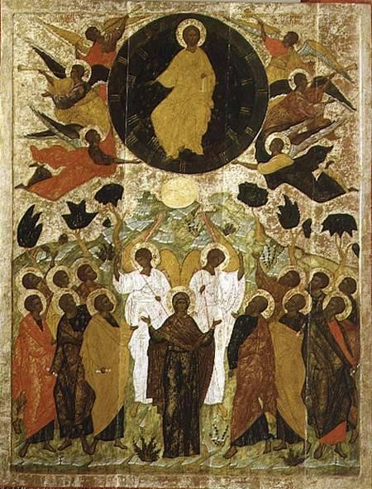
The Ascension, Russian, Novgorod School
http://www.edgeofenclosure.org/images/450_ascensionRussianNovgorodSchool.jpg

COMMUNAL REFLECTION (Betty: Slide, time 2:00, chime, stop slide)

(Richard): Next, Anne Regan will read to us from the Gospel of Matthew.

READING 2 Mt 28:16-20 (Anne Regan)
The eleven disciples went to Galilee,
to the mountain to which Jesus had ordered them.
When they saw him, they worshiped, but they doubted.
Then Jesus approached and said to them,
“All power in heaven and on earth has been given to me.
Go, therefore, and make disciples of all nations,
baptizing them in the name of Abba God, and of the Redeemer, and of the Holy Spirit,
teaching them to observe all that I have commanded you.
And behold, I am with you always, until the end of the age.”

REFLECTIVE QUESTIONS [Take a full breath after each question.] (Bill Fanelli)

What are the pros and cons of doubt for you?

How do you stay grounded in the power of Jesus?

How has your life been impacted by the promise of Jesus to be with you always?

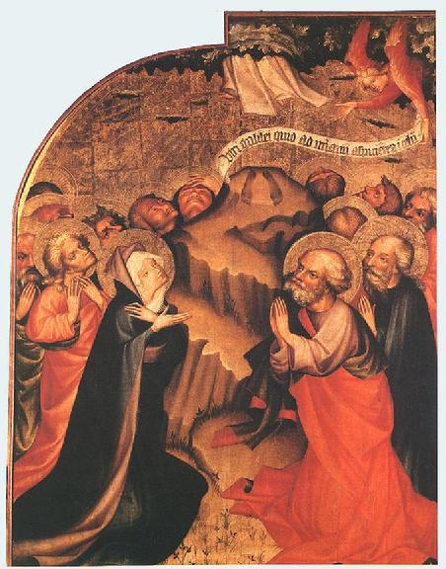
The Ascension, Master Thomas de Coloswar, 1427
http://www.edgeofenclosure.org/images/452_AscensionMasterThomasDeColoswar1427.jpg

COMMUNAL REFLECTION (Betty or other: Slide, time 2:00, chime, stop slide)

(Richard): Now Kathy Linabery will read an adaptation of a reflection on the Scriptures by Sister Mary M. McGlone, CSJ.

READING 3 “The Ascension of the Lord” Sister by Mary M. McGlone (Kathy Linabery)

With the Feast of the Ascension, we complete 40 days of Easter — and recognize that when Easter Monday comes most of us carry on as if we were living in ordinary time in a pre-Resurrection world.
It may be some comfort to know that we're not the first to do this. Listen carefully to our readings. Luke starts the Acts of the Apostles saying something like, "I already wrote a book that relates everything Jesus started to do and teach until the day he left." Luke seems to be imitating Mark whose Gospel opens with the line, "The beginning of the Gospel of Jesus Christ." Their readers’ responses would determine whether the beginning would evolve, radicalizing every dimension of human life, or fizzle out in tame piety.
And it seems that it took time and “many proofs” for the disciples to become genuine apostles. Matthew says that when the disciples met Jesus on the mountain, they "saw him, they worshiped, but they doubted." They were confused because their experience seemed like proof, and they were afraid to trust it.
Today's liturgy invites us to reflect again on the proofs we've contemplated during this Easter season: the empty tomb; interactions with Jesus on the road; receiving the breath of the Holy Spirit. Human life continually offers experiences that give us reason for hope and motivation to grow in our faith.
It would have been nice if Jesus had waited for his disciples to be certain. But Jesus didn't deal in the world of science and proofs; he operated in the realm of faith, a state of ongoing growth from doubt and fear to trust and peace. Even though the disciples weren’t fully ready, the moment came for Jesus to hand his mission over to them. From then until now, we are living in apostolic times, the era of practicing Christianity as experiential learning.
The disciples were very much like us. We will understand Easter when we begin to live as if death really has been overcome. We will know Christ in us by allowing his grace to move us to give our lives for others. Then we will experience living in a post-resurrection world – part of an apostolic community in the making.
REFLECTIVE QUESTIONS [Take a full breath after each question.] (Bill Fanelli)

When have you been handed a ministry you did not feel ready for?
What helps you move from “doubt and fear” to “trust and peace?”
What experiences give you post-resurrection hope?
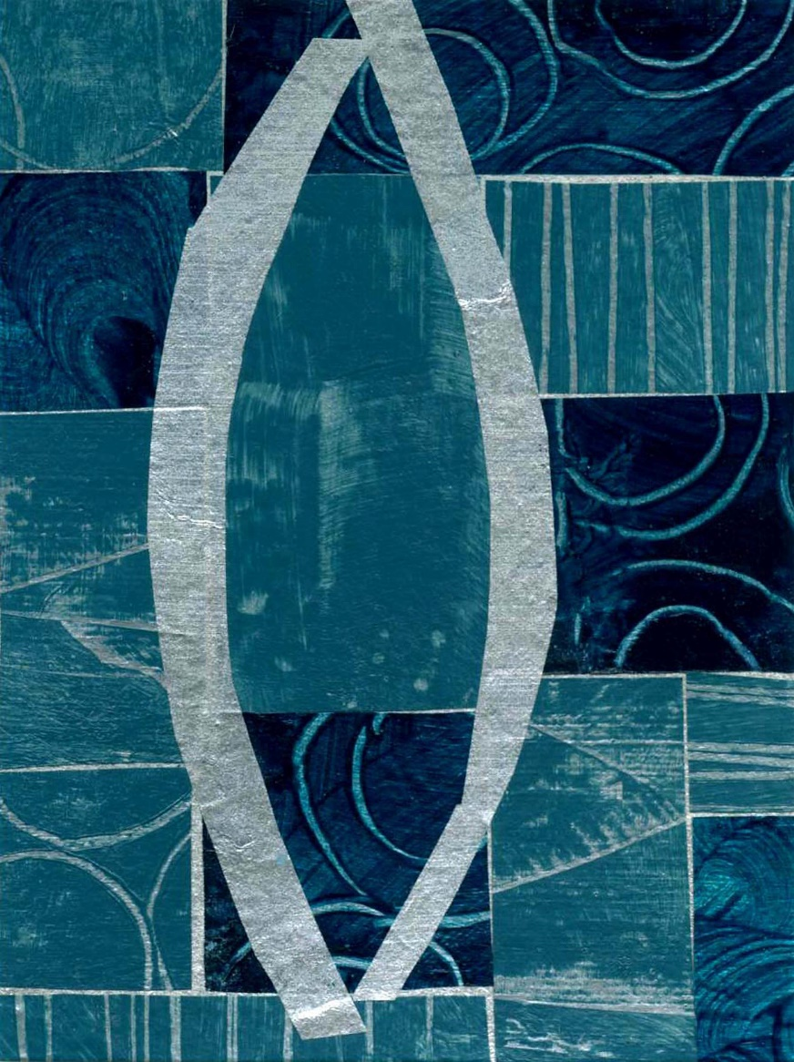
Ascension © Jan Richardson. janrichardson.com
COMMUNAL REFLECTION (Betty or other: Slide, time 2:00, chime, stop slide)

[Slight pause]

SHARING (Lin Linabery)

We invite you to share the essence that emerged in your heart this morning as you have reflected upon our readings and music. We welcome everyone who wants to speak, but we also know that the wisdom of this community includes both words shared and silent listening.

So let’s begin in silence as we gather our reflections. [Long-ish pause]

Now who would like to start our sharing? Remember to unmute yourself to speak and mute yourself again afterwards.

[Time for people to share their reflections.]

[If there is a long silence before anyone speaks:] Take whatever quiet you need before you speak.

[If there is extended silence during the sharing:] Is there anyone else who would like to share? [Pause for a slow, deep breath or two.]

[Stop by about 20 minutes after the hour.]

Thank you. Let us pause for a minute of silence to hold all that has been said, and to notice what is rising in us in response. [Long pause.] We can continue after the final song.

Holding onto what the Holy One is saying, we turn to God in prayer.

PRAYERS OF THE COMMUNITY (Bill Cavanaugh)

From today’s Scriptures, we learn that we have been called to continue the ministry of Jesus as part of the body of Christ, that this call is challenging, but that it is a challenge we do not face alone.

Our response today will be: “Loving God, hear our prayer.”

How we love certainty, control and calm. Help us to surrender to change, vulnerability and anxiety with trust in your peace and with hope for a future that is yet unknown. For this we pray. (All: Loving God, hear our prayer.)
Grant us the grace us to take time to pause, to be still, and to experience the love with which you enfold us. in order to open the eyes of our heart to see the face of Jesus in the crowd, and know the hope that flows from sharing the power of your divine compassion. For this we pray. (All: Loving God, hear our prayer.)
Accept our gratitude for the joy that comes from engaging in new relationships and new undertakings in a holy way, as life proceeds in an unending process of creative evolution. For this we pray. (All: Loving God, hear our prayer.)
Strengthen and inspire women religious, especially the Leadership Conference of Women Religious. Recreate them for your purpose in this place and in this time. For all of them, we pray. (All: Loving God, hear our prayer.)
For what else shall we pray? Please unmute yourself to speak, and mute yourself afterwards.

(After a person shares their prayer: ) ALL: “Loving God, hear our prayer.”
O You who love us more than we can imagine, we are grateful for this chance to give you our prayers, spoken and unspoken. We entrust the outcome to you. Amen.

OFFERTORY (Sr. Jo’Ann De Quattro)

Holy One, we bring you ourselves knowing you accept us just as we are and forgive us before we forgive ourselves.
We offer our whole selves to you, all that we have and all that we are. We pray that you will help us to be faithful in our witness. May we who have been given so much, share our gifts with others in need and love our neighbor as Jesus taught us.
Blessed Be!
CELEBRATION OF COMMUNION (Sr. Jennie Lechtenberg)

O Great Love, we are humbled and emboldened
to know that you trust us to be your body in this world.
We are part of that body as we let go of all that separates us from you,
and as we embrace one another and your entire creation with merciful love.
We give you thanks for your presence in and among us. [Pause.]

We remember the night before Jesus died.
At dinner with friends, Jesus knew all that would soon be asked of them,
and, loving them to the end, Jesus showed them how to care for each other
as they went out into the world.
First Jesus washed their feet
and said, “… as I have done for you, you should also do.”
Then he looked at what was in front of them, the bread and the wine,
gifts of Earth and the work of human hands, and blessed them.
So let us, too, invite God right now into what is front and center in our lives
knowing that God will indeed enter what we offer – and bless it. [Pause.]

Let us know God within ourselves so that we become God’s living presence in our world. [Pause.]

Holy One, we entrust ourselves to you and to one another.
Make us your bread of abundance. Make us your wine of joy.
Let even our fragments be plenty to share.
Blessed be.

To extend our communion, Kate Monagan will lead us in the Prayer of Jesus.

THE PRAYER OF JESUS (Kate Monagan)

Now let us join our hearts as if we could join our hands in harmony with our family throughout the world:

All (muted):

Heavenly Father, heavenly Mother,
Holy and blessed is your true name.
We pray for your reign of peace to come,
We pray that your good will be done,
Let heaven and earth become one.
Give us this day the bread we need,
Give it to those who have none.
Let forgiveness flow like a river between us,
From each one to each one.
Lead us to holy innocence
Beyond the evil of our days —
Come swiftly Mother, Father, come.
For yours is the power and the glory and the mercy:
Forever.
Amen.

FINAL BLESSING (Lynn Bufka)
Let us extend our hands in blessing of one another with the following words:
May God grant us the joy promised by Christ! –
Not by shielding us from all sorrows and pain,
But by strengthening us to bear it, as it comes;
Not by making our path easy,
But by making us sturdy to travel any path;
Not by taking hardships from us,
But by taking fear from our heart;
Not by granting us unbroken sunshine,
But by keeping our face bright, even in the shadows;
Not by making our life always pleasant,
But by showing us when people and their causes need us most,
and by making us anxious to be there to help.
God’s love, peace, hope and joy be with you.
– Author Unknown

Richard: Please join Reggie in singing “Send Down the Fire” by Marty Haugen.

CLOSING SONG (Reggie Ott)

Send Down the Fire

Verse 1
Call us to be your compassion,
Teach us the song of your love;
Give us hearts that sing,
Give us deeds that ring,
Make us ring with the song of your love.
Refrain:
Send down the fire of your justice,
Send down the rains of your love;
Come, send down the Spirit, breathe life in your people,
and we shall be people of God.

Verse 2
Call us to learn of your mercy,
Teach us the way of your peace;
Give us hearts that feel,
Give us hands that heal,
Make us walk in the way of your peace. (Repeat Refrain)
Verse 3
Call us to witness your Kingdom,
Give us the presence of Christ;
May your holy light
Keep us shining bright,
Ever shine with the presence of Christ. (Repeat Refrain)
RESOURCES
Introductory Quotation.
Richard Rohr Daily Meditation: God Is the Ground of Our Being, April 24, 2023. Meditations@cac.org.
Music and Art.
Opening Song. “Open Our Eyes” by Jesse Manabusan.
Opening Song Video Option.
https://www.youtube.com/watch?v=RA5PFQpIuFA (0.15 to 2:04)
Closing Song. “Send Down the Fire” by Marty Haugen.
https://catholichymn.blogspot.com/2016/01/send-down-the-fire.html
Closing Song Video Option.
https://www.youtube.com/watch?v=iWVq7Y22ti8 (10 to 3:00)

"The Ascension," 14th-century Italian embroidery (Metropolitan Museum of Art, The Cloisters Collection, 1960) https://www.ncronline.org/files/Ascension%20c_0.jpg

“The Ascension,” Russian, Novgorod School
http://www.edgeofenclosure.org/images/450_ascensionRussianNovgorodSchool.jpg

“The Ascension,” Master Thomas de Coloswar, 1427
http://www.edgeofenclosure.org/images/452_AscensionMasterThomasDeColoswar1427.jpg

“Ascension,” Jan Richardson.
janrichardson.com

Scripture.
Adapted from https://bible.usccb.org/bible/readings/052123-Ascension.cfm
Reflection on Scriptures.
Adapted from Mary M. McGlone, CSJ, “The Ascension of the Lord,” May 24, 2020. https://www.ncronline.org/may-24-2020-ascension-lord

