SOLIDARITY WITH SISTERS COMMUNAL PRAYER
MAY 7, 2023 - FIFTH SUNDAY OF EASTER
“You will do even greater works…”
HELLOs (Betty Thompson & Suzie De Quattro)
Betty mutes everyone.
WELCOME (Kathy Linabery)

Welcome, everyone!
- I am Kathy Linabery. Norb Bufka, Deb Ballard, Lin Linabery and I had the joy
of preparing today’s liturgy with the much-appreciated input from Suzie & Betty
- Introductions - people who haven’t been here before?
- Our thanks to the people who will be reading and leading us in prayer today:
Maryann Dolan, Richard McGinnis, Kathy & Bill Cavanaugh, Peggy Thompson,
Sr. Vera Ruotolo, Sr. Jacqueline Quinn, Judy Sholes, Marilyn Voigt, Lynn Bufka
and Linda Donaldson who will be leading us musically.
- We are always looking for new readers and are grateful for all readers. If you are
available on May 14, contact Judy Sholes; for May 21, contact Richard McGinnis.
You can leave a message in Chat or email the planners.

SETTLING IN (BettyThompson)
Betty: show this slide during Settling in.

Sunrise in the forest
Take a moment to breathe and to imagine yourself alone in the forest with the sun
rising above you.
(Long pause)
With another deep breath, imagine you are with a dear companion who knows
you well.
(Long pause)
Finally, take a third breath to enter into our community this morning, just as you are:
welcomed, honored, and loved.
(Pause)

OPENING SONG Anthem (Linda Donaldson)

REFRAIN: We are called, we are chosen.
We are Christ for one another.
We are promised to tomorrow,
while we are for him today.
We are sign, we are wonder.
We are sower, we are seed.
We are harvest, we are hunger.
We are question, we are creed.

VERSE: Then where can we stand justified? In what can we believe?
In no one else but Christ who suffered,
nothing more than Christ who rose.
Who was justice for the poor.
Who was rage against the night.
Who was hope for peaceful people.
Who was light.

CALL TO WORSHIP ( Judy Sholes )

Let us rejoice, for Jesus Christ is risen! Alleluia! Alleluia!’

All: Christ is risen indeed! Alleluia! Alleluia!

We come together once again to stand beside the disciples as they - and we -
deepen our experience of the Risen One alive with us. It is the light of the Risen
One that lets us see our next step. And so we pray:

Holy One, over and over during this season we hear Jesus say, “Peace be with you.”
Teach us how to be a community of contagious peace and hope.
In a world and among loved ones with heart-breaking needs, show us how to be
your heart.
May we inquire, nudge, and challenge each other to imagine what none of us
could conceive alone.
Blessed be.

Kathy Linabery will introduce us to today’s theme.

INTRODUCTION TO THEME (Kathy Linabery)

This morning we have another opportunity to respond to God’s love revealed to us in Jesus, to live differently in openness and trust, so the Spirit can be heard.

Our story from Acts gives us a clear picture of how Jesus’ powerful works were continued in the early church through the power of the Spirit.

The Hellenists, that is the Greek-speaking Jews who would have been immigrants
to Jerusalem, are complaining that their widows are being treated like second-class
citizens. Those who speak Aramaic (the “Hebrews”) are getting preferential treatment. This is a divisive situation. Something has to be done.

Notice the way the decision about how to respond to the problem is made. The apostles do not make the decision all by themselves. Rather, they assemble the
community, explain the problem, and present a proposal to the community that is
unanimously accepted. The apostles do not themselves choose the new leadership, but they leave that up to the community.

In Acts we see deep listening, that allows people to speak openly, respectfully from different perspectives. This is an early Christian example of synodality which Pope Francis is bringing back to the People of God.

We remain with Acts in our second reading and share excerpts and insights from a homily given by an Australian religious sister, Elizabeth Young. We are reminded that our discipleship, rooted in our baptism, is a call to both women and men - with no distinction of importance. Isn’t this what Pope Francis suggests in his urging the Church toward synodality? Isn’t this a way for us to stand together in faith, hope, and love like the early followers of Jesus?

In our third reading, of John’s Gospel, Jesus invites his disciples to come to him and put their lives into his hands. We do that by living in relationship with him, listening to his
teaching and following his way. That’s how we will come to the life he promises.

(Slight pause)

Now Kathy Cavanaugh will read from Acts 6:1-6 and Bill Cavanaugh will offer
questions that will lead us into silence.

READING 1 Acts 6:1-6 (Kathy Cavanaugh)

As the number of disciples continued to grow, the Hellenists complained against
the Hebrews because their widows were being neglected in the daily distribution.
So the Twelve called together the community of the disciples and said,
“It is not right for us to neglect the word of God to serve at table.
Brothers, select from among you seven reputable men,
filled with the Spirit and wisdom, whom we shall appoint to this task,
whereas we shall devote ourselves to prayer and to the ministry of the word.”
The proposal was acceptable to the whole community,
They presented these men to the apostles who prayed and laid hands on them.
QUESTIONS 1 (Bill Cavanaugh)

What in this story can guide you toward action about injustices in the Church now?

Recall a time when you were an outsider in a group. What did people do either to keep you outside, or to make you at home?

How would you feel if a leader fully entrusted an important problem to the group as a whole?

COMMUNAL SILENCE (Betty: Share slide, time 2:00, chime, stop slide)

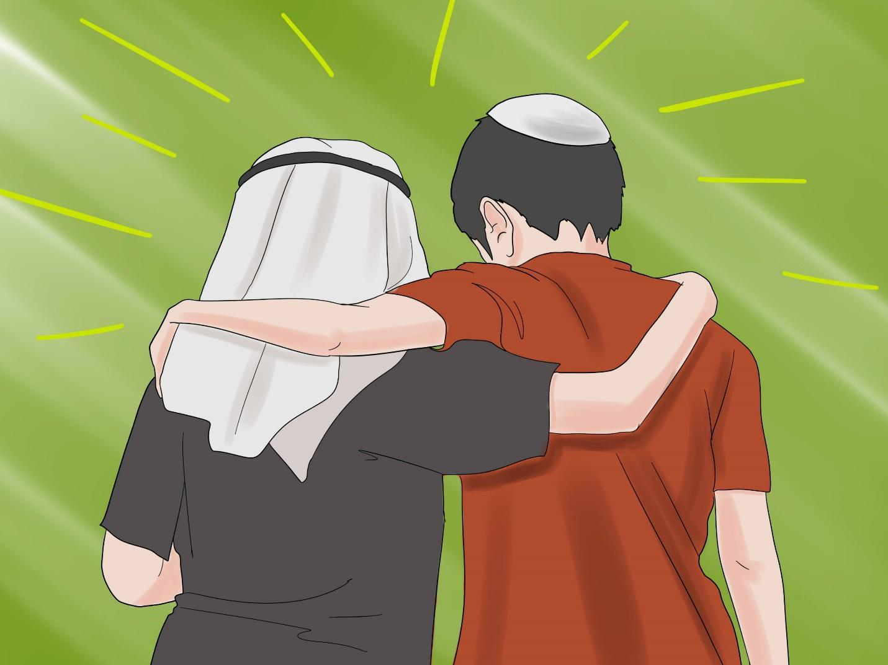
Muslim and Jewish boys

Betty: Now Maryann Dolan will read excerpts from a homily given by Sr. Elizabeth Young, and some thoughts about ministry by Pope Francis.

READING 2 (Maryann Dolan)

In my school, St Mary MacKillop Memorial School, there was a red sign stuck up on the office door: “Never see a need without doing something about it.” Those words came back to me as I reflected on our reading from Acts 6.

It takes place in the early days of the Church and it’s a story of the Church seeing a need and doing something about it. It’s a story of delegating ministers. Now, in your bibles, the chapter heading might be something like ‘The Seven Chosen to Serve’. The community heard the complaint that some were being overlooked. And the Twelve called Seven others to respond and then they prayed, laid their hands on them, and sent them off for their ministry.

So let’s start with seeing the need. In this story, the Hellenist, or Greek-speaking widows, were being neglected. Though it may say in your bible that it was about food, it’s not there in the original Greek text. Recent scholars claim they were being neglected in ministry, in ministry in their own language and culture. So let’s be creative, said the Church. Let’s respond to the need. So the Seven were called to ministry of the word at the widows’ own tables; they were to reach out to them where they were.

Pope Francis recently talked about ministry:
The full extent of the ministry of the church is broader than catechist, lector, and eucharistic minister. Ever since the first Christian communities, ministry involves all the faithful. Many ministries, while not requiring a formal institution by the church, are, nevertheless, inspired by the Holy Spirit for the good of the church and the world.

QUESTIONS 2 (Bill Cavanaugh)

What creative ways can be used to bring the marginalized into the mainstream of Church life? How can you as an individual do the same?

When have you been part of a community whose demographics changed in important ways? How did this change you and your relationship to the community?

Pope Francis refers to undefined but real “ministries” beyond the traditional list. How would you name your personal ministry?

COMMUNAL SILENCE (Betty: Share slide, time 2:00, chime, stop slide)
Picture of Dorothy Day with caption to read:
Dorothy Day: Founder of the Catholic Worker Movement

Betty: Now Marilyn Voigt will read from John 14:1-12

READING 3 Portions of John 14:1-12 (Marilyn Voigt)

Jesus said, “Do not let your hearts be troubled. You have faith in God; have faith also in me.
Where I am going you know the way.”
Thomas said to him, “Master, we do not know where you are going;
how can we know the way?”
Jesus told him,

“I myself am the Way - I am Truth, and I am Life.

If you really knew me, you would know Abba God also.

The words I speak are not spoken of myself, it is Abba God, living in me.

Believe me that I am in God and God is in me,
or else believe because of the works I do.

The truth of the matter is, anyone who has faith in me will do the works I do -
and greater works besides.”

QUESTIONS 3 (Bill Cavanaugh)

How has someone inspired you to follow Jesus’ radical way of selfless service
to others?

In your daily life, in what ways are you choosing Jesus as your “way?”
What other “ways” are you tempted to choose?

How can you do greater works than Jesus?

COMMUNAL SILENCE (Betty: Share slide, time 2:00, chime, stop slide)
Two Pictures of Dr. Fauci side by side with caption to read:
Dr. Anthony Fauci - Global Program providing treatment
for millions of people with AIDS.

Betty: Lynn Bufka will lead our sharing.

SHARING (Lynn Bufka)

We invite you to share the essence that emerged in your heart this morning as you have
reflected upon our readings and music. We welcome everyone who wants to speak, and
we also know that the wisdom of this community includes both words shared and silent
listening.

So let’s begin in silence as we gather our reflections. [Long-ish pause]

Now who would like to start our sharing?
[Sharing]

[If there is extended silence during the sharing:] Is there anyone else who would like to
share? [Pause for a few slow, deep breaths.]

[Stop by 20 minutes after the hour.]

Thank you. Let us pause for a minute of silence to hold all that has been said, and to
notice what is rising in us in response. [Long pause.] We can continue after the final
song, as we often do.

Holding onto what the Holy One is saying, we turn to God in prayer.

PRAYERS OF THE COMMUNITY (Peggy Thompson)

Let’s notice the prayers that arise in us now. (Pause) Our response will be:

Healing One, hear our prayer

For the marginalized in our society and Church.
For this we pray: Healing One, hear our prayer.

For the LCWR that, when they see problems of marginalization, they continue to take creative steps to resolve them.
For this we pray: Healing One, hear our prayer.

That the polarization in our society and Church can be resolved by faith in Jesus Christ and his empowering presence.
For this we pray: Healing One, hear our prayer.

Peggy: For what else shall we pray? Please end your petition with:
For this we pray:
Healing One, hear our prayer.

(People share prayers. After all have shared, Peggy finish with the following prayer:)

O You who love us more than we can imagine, we are grateful for this chance to give you our prayers, spoken and unspoken. We entrust the outcome to you. Blessed be.

OFFERTORY (Sr. Jacqueline Quinn )

In this Easter season, we celebrate that we share in Jesus’ resurrection. Reflect upon
how this new “way of Jesus” is rising in you like yeast this week. Where will you offer this new bread you have become for the life and good of the world?
(Pause)

Let us pray:
Walk near me, Faithful Companion, and nudge me to be generous and
unafraid to offer myself and my heart for the good of others. Blessed Be.

CELEBRATION OF COMMUNION (Sr. Vera Ruotolo)

Since once again we have neither bread nor wine nor altar, we raise our hearts beyond these elements, up to the unknowable mystery of the Real itself;

We shall make the whole earth our altar… and on it offer all the labors and sufferings of the world, the places of light and darkness, of beauty and devastation … All the things in the world to which this day will bring increase; all those that will diminish; all those, too that will die: all of them, Creator, we gather in our grateful arms, and ask your blessing:

To grow, to flower, to be bread for others this day, to become the body of Christ.

All (muted): Blessed Be.

THE PRAYER OF JESUS (Richard McGinnis)

Now let us join our hearts in the words of the Polynesian and Maori people and the New Zealand Anglican community:

Eternal Spirit,
Earth-maker, Pain-bearer, Life-giver,
Source of all that is and that shall be,
Father and Mother of us all,
Loving God, in whom is heaven:
The hallowing of your name echo through the universe;
The way of your justice be followed by the peoples of the world;
Your heavenly will be done by all created beings;
Your commonwealth of peace and freedom
sustain our hope and come on earth.
With the bread we need for today, feed us.
In the hurts we absorb from one another, forgive us.
In times of temptation and test, strengthen us.
From trial too great to endure, spare us.
From the grip of all that is evil, free us.
For you reign in the glory of the power that is love,
now and forever. Blessed Be!

FINAL BLESSING (Kathy Linabery)

In this century and in any century,
Our deepest hope, our most tender prayer,
Is that we learn to listen.
May we listen to one another in openness and mercy.
May we listen to plants and animals in wonder and respect.
May we listen to our own hearts in love and forgiveness.
May we listen to God in quietness and awe.
And in this listening,
Which is boundless in its beauty,
May we find the wisdom to cooperate
With a healing spirit, a divine spirit
Who beckons us into peace and community and creativity.
We do not ask for a perfect world.
But we do ask for a better world.
We ask for deep listening.

CLOSING SONG They’ll Know We Are Christians (Linda Donaldson)

Refrain: And they’ll know we are Christians by our love, by our love,
Yes, they’ll know we are Christians by our love.

1. We are one in the Spirit, we are one in the Lord,
We are one in the Spirit, we are one in the Lord,
And we pray that all unity will one day be restored: Refrain

2. We will walk with each other, we will walk hand in hand,
We will walk with each other, we will walk hand in hand,
And together we’ll spread the news that God is in our land: Refrain

3. We will work with each other, we will work side by side,
We will work with each other, we will work side by side,
And we’ll guard human’s dignity and save human’s pride: Refrain

4. All praise to the Father, from whom all things come,
And all praise to Christ Jesus, his only son,
And all praise to the Spirit who makes us one: Refrain

Resources:
Laity share baptismal call to ministry, service, pope says https://www.ncronline.org/vatican/vatican-news/laity-share-baptismal-call-ministry-service-pope-says
Catholic Women Preach
5th Sunday of Easter May 5, 2023
Elizabeth Young, RSM (Sisters of Mercy) – who has degrees in both Circus Arts and Theology, as her bio says at https://www.catholicwomenpreach.org/preacher/elizabeth-young

Final Blessing:
Dr. Jay McDaniel
Professor of Religion
Hendrix College, Conway, Arkansas

