Solidarity with Sisters’ Communal Prayer
April 23, 2023 – third sunday of easter

“Weren’t our hearts burning inside us?”
The Emmaus Story by Josef Mahler

HELLOs (Betty Thompson & Suzie De Quattro)

Betty mutes everyone.

WELCOME (Terri Butel)

Welcome, everyone!
- I am Terri Butel and I prepared our prayer for today.
- Introductions – people who haven’t been here before?
- My thanks to the people who will be reading and leading us in prayer today: Alicia and George Urban, Maryann Dolan, Sr. Vera Ruotolo, Sr. Jo’Ann De Quattro, Lynn Bufka, Peg Duchesne, Sr. Jennie Lechtenberg, Kathy Linabery - and Reggie Ott will lead us in our music.
- We are always looking for new readers and grateful for all readers. If you are available on April 30, contact Suzie De Quattro, and for May 7, contact Kathy Linabery. You can leave a message in Chat or email the planners.

SETTLING IN (Lynn Bufka)
(Terri: share slide)
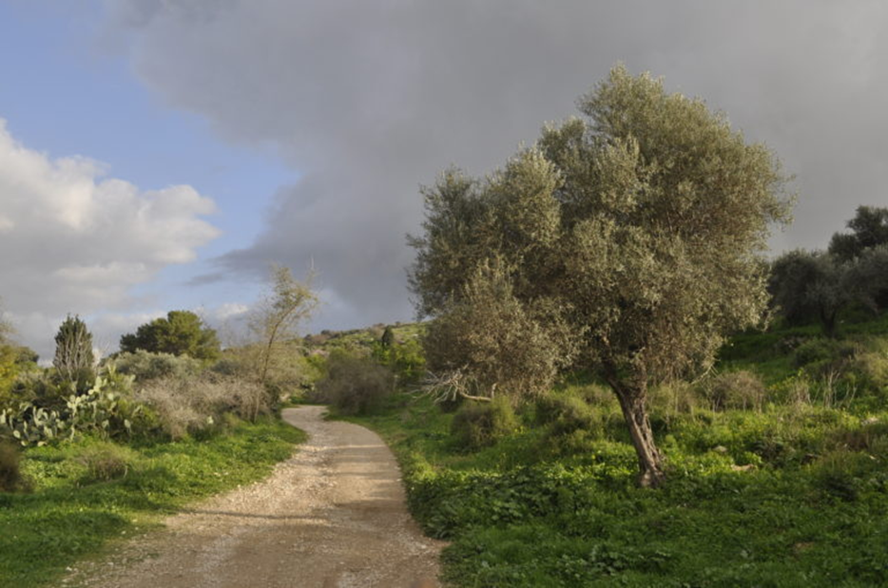
Emmaus Trail, photo by Henri Gourinard

Take a moment to breathe and to imagine yourself alone on this dusty and winding road, the Emmaus trail. (Long pause)
With another deep breath, imagine you are walking with a dear companion who knows you and the road well. (Long pause)
Finally, take a third breath to enter into our community this morning, just as you are, welcomed, honored and loved. (pause)

Now let us begin our prayer together by singing In the Breaking of the Bread, led by Reggie Ott.

OPENING SONG - In the Breaking of the Bread (Reggie Ott)

Refrain: In the breaking of the bread
We have known him; we have been fed.
Jesus the stranger, Jesus the Lord,
Be our companion, be our hope.

Once I was helpless, sad and confused;
darkness surrounded me, courage removed.
And then I saw him by my side.
Carry my burden, open my eyes. Refrain

CALL TO WORSHIP (Sr. Jo’Ann De Quattro & Sr. Jennie Lechtenberg)

Let us rejoice, for Jesus Christ is risen! Alleluia! Alleluia!

All: Christ is risen indeed! Alleluia! Alleluia!

We come together today to stand beside the disciples as they – and we – have our eyes and hearts opened to recognize the Risen One alive and walking with us. And so we pray:

Holy One, over and over during this season we hear Jesus say, “Peace be with you.”
Teach us how to be a community of contagious peace and hope.
In a world and among loved ones with heart-breaking needs,
show us how to be your heart.
May we inquire, nudge, and challenge each other
to imagine what none us could conceive alone.
Amen.

Terri Butel will introduce us to today’s theme.

INTRODUCTION TO THEME (Terri Butel)

Today’s theme is about the Emmaus disciples’ grief at the death of Jesus, as well as their deep disappointment that Jesus failed to liberate Israel from Roman occupation. The profound effect on the two disciples causes them to walk away, not only from Jerusalem, but from the community who shared their hopes and can most relate to their feelings. It is about God meeting us where we are. Even in difficult times we may experience deepened faith and restored energy for mission.

(Slight pause)

Now Alicia Urban will read the first part of the Road to Emmaus from Luke’s Gospel, and Kathy Linabery will offer questions that will lead us into silence.

READING 1 Lk 24:13-35 (Alicia Urban)

Two of the disciples were making their way to a village called Emmaus, about seven miles from Jerusalem - discussing all that had happened as they went.

While they were discussing these things, Jesus approached and began to walk along with them, though they were kept from recognizing Jesus, who asked them, "What are you two discussing as you go your way?"

They stopped and looked sad. One of them, Cleopas, asked him, "Are you the only one visiting Jerusalem who doesn’t know the things that have happened these past few days?"

Jesus asked, "What things?"

They said, "About Jesus of Nazareth, a prophet powerful in word and deed in the eyes of God and all the people – how the chief priests and leaders delivered him up to be condemned to death and crucified him. We were hoping that he was the One who would set Israel free. Besides all this, today - the third day since these things happened - some women of our group have just brought us some astonishing news. They were at the tomb before dawn and didn’t find the body; they returned and informed us that they had seen a vision of angels, who declared that Jesus was alive. Some of our number went to the tomb and found it to be just as the women said, but they didn’t find Jesus."

QUESTIONS 1 (Kathy Linabery)

Where are you on the road between Jerusalem and Emmaus and who is your companion?

Reflect on your great hope for our church. How are you walking away from that hope? How are you hastening toward it?

When you feel confused about where God is in the events you witness, where do you go? With whom do you talk?

COMMUNAL SILENCE (Terri: Share slide, time 2:00, chime, stop slide.)

Terri Butel: Now George Urban will continue the Road to Emmaus reading from the Gospel of Luke.

READING 2 (George Urban)

Then Jesus said to them, "How slow you are to believe all that the prophets have announced!" Then, beginning with Moses and all the prophets, Jesus interpreted for them every passage of Scripture which referred to the Messiah. By now they were near the village, and Jesus appeared to be going further. But they said eagerly, "Stay with us. It’s nearly evening - the day is practically over." So Jesus went in and stayed with them.

After sitting down with them, Jesus took bread, said the blessing, then broke the bread, and began to give it to them. With that their eyes were opened and they recognized Jesus, who immediately vanished from their sight.

They said to one other, "Weren’t our hearts burning inside us as this one talked to us on the road and explained the Scriptures to us?" They got up immediately and returned to Jerusalem, where they found the Eleven and the rest of the company assembled. They were greeted with, "Christ has risen! It’s true! Jesus has appeared to Simon!" Then the travelers recounted what had happened on the road, and how they had come to know Jesus in the breaking of bread.

(Slight pause)

QUESTIONS 2 (Kathy Linabery)

Who or what has most helped you to interpret Scripture?

What surprise encounter rejuvenated your energy for mission?

When have you made a U-turn in your understanding of your faith, like these disciples? In what direction are you headed now?

COMMUNAL SILENCE (Terri: Share slide, time 2:00, chime, stop slide.)

Terri Butel: Now Peg Duchesne will read from a reflection by Sister Joyce Rupp.

READING 3 From a reflection by Joyce Rupp (Peg Duchesne)

In “Fragments of Your Ancient Name”, Joyce Rupp names God as “Companion” and prays:
“Companion: cum panis, Latin for “with bread.”
Scriptural memories of how you were present
At the farewell table, blessing, breaking, sharing.
Being on the road with discouraged disciples,
Revelation coming forth, again blessing bread.
Today your companioning still brings bread
To each who meets you at table or on the road.
The bread of kinship and hope. The inner peace
That the heart requires and each person desires,
The nourishing sustenance to keep love alive.”

(Slight pause)

QUESTIONS 3 (Kathy Linabery)

When have you been offered unexpected hospitality that opened your eyes to new understanding?

When have you offered the bread of ‘kinship and hope’ to someone?

COMMUNAL SILENCE (Terri: Share slide, time 2:00, chime, stop slide.)

Terri Butel: Lynn Bufka will lead our sharing.

SHARING (Lynn Bufka)

We invite you to share the essence that emerged in your heart this morning as you have reflected upon our reading and music. We welcome everyone who wants to speak, and we also know that the wisdom of this community includes both words shared and silent listening.

So let’s begin in silence as we gather our reflections. [Long-ish pause]

Now who would like to start our sharing?
[Sharing]

[If there is extended silence during the sharing:] Is there anyone else who would like to share? [Pause for a slow, deep breath.]

[Stop by 20 minutes after the hour.]

Thank you. Let us pause for a minute of silence to hold all that has been said, and to notice what is rising in us in response. [Long pause.] We can continue after the final song, as we often do.

Holding onto what the Holy One is saying, we turn to God in prayer.

PRAYERS OF THE COMMUNITY (Sr. Jo’Ann De Quattro &
Sr. Jennie Lechtenberg)

Let’s pause to notice the prayers that arise in us now. (Pause) Our response will be: Faithful Companion, hear our prayer.

In thanksgiving for those companions who walk with us in our journey of faith, especially for this SWS community. For this we pray, Faithful Companion, hear our prayer.

God walking with us, strengthen and inspire women religious, especially the Leadership Conference of Women Religious. Recreate them for your purpose in this place and in this time. For this we pray, Faithful Companion, hear our prayer.

Merciful God, it is hard to keep track of all who are suffering terrible injustice, and whose lives have been arrested by violent storms and gun violence. Keep us attentive to the headlines and to the people that the headlines don’t mention; inspire us to do something! For this we pray, Faithful Companion, hear our prayer.

On this Earth Day weekend, deepen our experience of connection with all people and all creation. May we open our eyes and hearts to protect and preserve resources and our planet for the good of all. For this we pray, Faithful Companion, hear our prayer.

For what else shall we pray? Please end your prayer with “For this we pray, Faithful Companion, hear our prayer.”

(People share prayers.) Faithful companion, hear our prayer.

O You who love us more than we can imagine, we are grateful for this chance to give you our prayers, spoken and unspoken. We entrust the outcome to you. Amen.

OFFERTORY (Maryann Dolan)

In this Easter season, we celebrate that we share in Jesus’ resurrection. Reflect upon how this new life is taking root in you this week. Where will you offer this new bread you have become for the life and good of the world?
(Pause)
Let us pray: Walk near me, Faithful Companion, and nudge me to be generous and unafraid to offer myself and my heart for the good of others. Amen.

CELEBRATION OF COMMUNION (Sr. Vera Ruotolo)
(from Pierre Teilhard de Chardin’s “Mass on the World”)

Since once again we have neither bread nor wine nor altar, we raise our hearts beyond these elements, up to the unknowable mystery of the Real itself;

We shall make the whole earth our altar… and on it offer all the labors and sufferings of the world, the places of light and darkness, of beauty and devastation … All the things in the world to which this day will bring increase; all those that will diminish; all those, too that will die: all of them, Creator, we gather in our grateful arms, and ask your blessing:

To grow, to flower, to be bread for others this day, to become the body of Christ.

All (muted): Amen

To extend our communion Kathy Linabery will lead us in the Prayer of Jesus.

THE PRAYER OF JESUS (Kathy Linabery)

Now let us join our hearts as if we could join our hands to pray in harmony with our family throughout the world:

All (muted):

Our Father, Our Mother, you are here among us.
Blessed be Your Creation.
May Your reign be a reality here on earth.
May we become more interested in building Your kin-dom here and now
rather than waiting for it to come down from above.
Let us share our bread with those who hunger.
Let us learn to forgive as well as to receive forgiveness.
Help us through the time of temptation, delivering us from all evil.
For ours are the eternal blessings that you pour upon the earth.
Amen.

FINAL BLESSING A Prayer for our Earth (Maryann Dolan)
Laudato Si’ (246)

All-powerful God, you are present in the whole universe and in the smallest of your creatures. You embrace with your tenderness all that exists.

Pour out upon us the power of your love, that we may protect life and beauty.
Fill us with peace, that we may live as brothers and sisters, harming no one.

O God of the poor, help us to rescue the abandoned and forgotten of this earth, so precious in your eyes.

Bring healing to our lives, that we may protect the world and not prey on it,
that we may sow beauty, not pollution and destruction.

Touch the hearts of those who look only for gain at the expense of the poor and the earth. Teach us to discover the worth of each thing, to be filled with awe and contemplation, to recognize that we are profoundly united with every creature as we journey towards your infinite light.

We thank you for being with us each day.
Encourage us, we pray, in our struggle for justice, love and peace.
Amen.

Now Reggie Ott will lead us in “We Are Walking”.

CLOSING – “We Are Walking” (South African) (Reggie Ott)

We are marching in the light of God,
We are marching in the light of God!
We are marching in the light of God,
We are marching in the light of God!
We are marching marching…
We are marching Oh Oh…
We are marching in the light of God!
We are marching marching,,,
We are marching Oh Oh…
We are marching in the light of God!
We are living in the love of God,
We are living in the love of God!
We are living in the love of God,
We are living in the love of God!
We are living living…
We are living Oh Oh…
We are living in the love of God!
We are living living…
We are living Oh Oh…
We are living in the love of God!

RESOURCES

Emmaus art: The Emmaus Story by Josef Mahler., https://beingbenedictine.com/2020/05/14/hearts-burning-within-us/
Emmaus trail image: Photo courtesy of Henri Gourinard, https://www.biblicalarchaeology.org/daily/biblical-sites-places/the-emmaus-trail/
Opening Song: In the Breaking of the Bread, Bob Hurd and Michael Downey, OCP.
Reading 1 & 2: Luke 24:13-35, Inclusive Bible: The First Egalitarian Translation, Copyright 2007 by Priests for Equality.
Reading 3: “Fragments of Your Ancient Name”, Joyce Rupp, Nov. 30 name for God, Green Press Initiative, 2011.
Celebration of Communion: The French priest, Pierre Teilhard de Chardin, who at one time was silenced by the Church for his teachings, was not able to celebrate Mass when he was out in the Ordos desert in China. This is an excerpt from his “Mass on the World” [https://www.tarsus.ie/resources/SSS-2020/The-Mass-On-The-World.pdf ]. This very short passage of his 9 page “Mass” was inspired by Joyce Rupp & Macrina Wiederkehr’s book, Circle of Life: The Heart’s Journey Through the Seasons, p.49.
Final Blessing: A Prayer for our Earth - Laudato Si’ (246), https://catholicclimatecovenant.org/resource/pope-francis-prayer-our-earth
Closing Song: “We Are Walking” (South African traditional hymn), https://digitalsongsandhymns.com/songs/9860-1

