Solidarity with Sisters’ Communal Prayer
October 16, 2022 – 29th Sunday in Ordinary Time

“A woman in that city who had been widowed kept coming to the judge …”
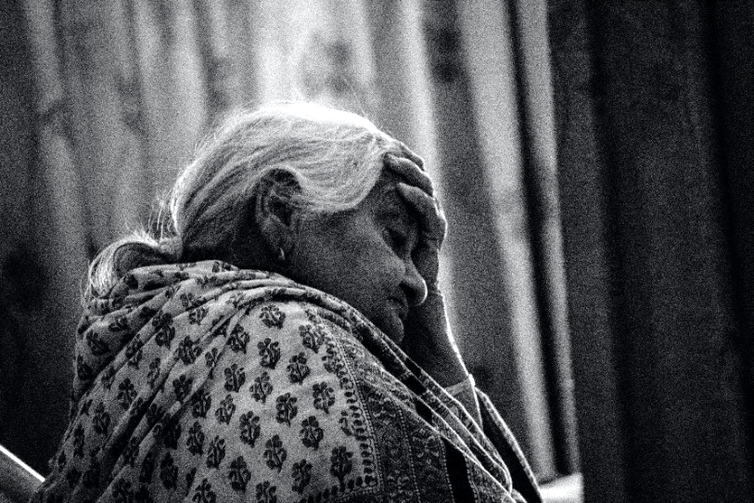

HELLOs and then Betty mutes everyone. (Betty, Terri)

WELCOME (Terri Butel)

Welcome, everyone!
- Introductions – people who haven’t been here before?
- I prepared today’s communal prayer with input from Suzie and Betty – thank you!
- Thanks to the people who will be reading and leading us in music and prayer today: Lynn Bufka, Linda Donaldson, Ann Masters, Arlene McGarrity, Reggie Ott, and Nancy Sushinsky.
- If you’d like to read on future Sundays, please get in touch.

SETTLING IN

Let your breath bring you into quiet so you can be attentive to each other and to the Spirit. Notice your breath as it goes in and out…. Let it slow and deepen… and slowly fill you with the peace of Christ. We begin with 3 deep breaths. One to be here… one to be together… and one to know the Spirit who never leaves us.

OPENING SONG O Lord, Hear My Prayer (Taize) (fade at 2:15)
https://www.youtube.com/watch?v=8BWKmahZgLM
O Lord hear my prayer, O Lord hear my prayer
When I call, answer me…
O Lord hear my prayer, O Lord hear my prayer
Come and listen to me. (repeat)
GREETING/CALL TO WORSHIP Lynn Bufka

Beloved Community, rejoice! God comes out to meet us, to embrace our heartfelt pleadings with compassion and love.

All: Thanks be to God, whose mercy is unending!

Holy One, we gather again to hear the Word and to ponder what wisdom it holds for us this day. Though we gather from far and wide to listen together, your words are personal for each of us. May they enlighten us with new understanding and new resolve to do what we must do, to never stop praying, and to be a light for all, in all the places we live.

All: Amen.

IntroDUCTION to Theme Linda Donaldson

Today we hear Jesus’ parable of the Persistent Widow and Heartless Judge. In our prayers we may sometimes feel like the widow: alone, powerless, a victim of unfairness, disregarded, the least and last person in line. One theme for today might be persistence in just causes: What is it like to persist despite resistance? How do we discern when to put our energy elsewhere?

Another theme might be our persistence in prayer. Real power rests in those who tap into a power accessible only to those who ask and seek and knock. Prayer sets God loose. How do we continue to cheerily bring our intentions to prayer over the long haul? Are we on a first name basis with God? What do seemingly unanswered prayers reveal about us?

[Slight pause]

Now Ann Masters will read from the Gospel of Luke. Arlene McGarrity will offer questions that will lead us into a period of silent reflection.

READING 1: Luke 18:1-8 Ann Masters
Jesus told the disciples a parable on the necessity of praying always and not losing heart.
"Once there was a judge in a certain city who feared no one – not even God. A woman in that city who had been widowed kept coming to the judge and saying, 'Give me legal protection from my opponent.’ For a time the judge refused, but finally the judge thought, ‘I care little for God or people, but this woman won’t leave me alone. I’d better give her the protection she seeks, or she’ll keep coming and wear me out!’'"
Jesus said, "Listen to what this corrupt judge is saying. Won’t God then do justice to the chosen who call out day and night? Will God delay long over them? I tell you, God will give them swift justice.”

QUESTIONS 1 Arlene McGarrity

How have you felt when you have persisted in something despite strong resistance? (Pause)
How have you felt when someone persisted in asking you for something that you ignored or refused? (Pause)
How do you feel when you see no change after persistent prayer? (Pause)

COMMUNAL SILENCE (Betty: Share slide w/questions, time 2:00, chime, stop slide.)

Betty: Now Regggie Ott will read an account about the civil rights march from Selma in 1965.

READING 2: "Bloody Sunday," 1965 (Reggie Ott)
In 1965, at the height of the modern civil rights movement, activists organized a march for voting rights, from Selma, Alabama, to Montgomery, the state capital. On March 7, some 600 people assembled at a downtown church, knelt briefly in prayer, and began walking silently, two-by-two through the city streets.
With Hosea Williams of the Southern Christian Leadership Conference leading the demonstration, and John Lewis, Chairman of the Student Nonviolent Coordinating Committee, at his side, the marchers were stopped as they were leaving Selma, at the end of the Edmund Pettus Bridge, by some 150 Alabama state troopers, sheriff ’s deputies, and possemen, who ordered the demonstrators to disperse.
One minute and five seconds after a two-minute warning was announced, the troops advanced, wielding clubs, bullwhips, and tear gas. John Lewis, who suffered a skull fracture, was one of fifty-eight people treated for injuries at the local hospital. John Lewis was 25 years old.
Many years later, John Lewis wrote: “We were beaten, we were tear-gassed. I thought I was going to die on this bridge. But somehow and some way, God almighty helped me here. We cannot give up now. We cannot give in. We must keep the faith, keep our eyes on the prize.”

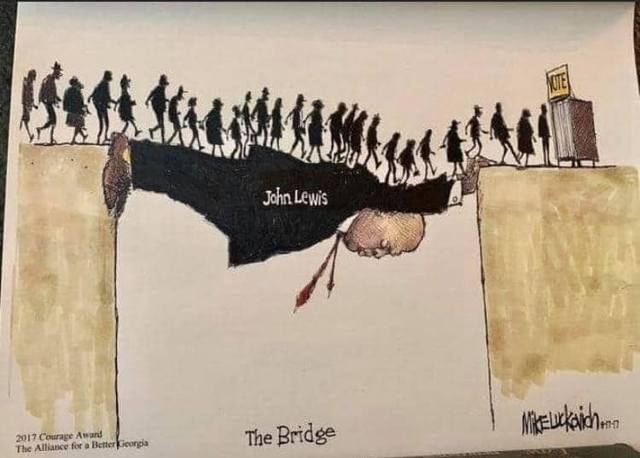

QUESTIONS 2 Arlene McGarrity

What is “the prize” for which you persist at this point in your life? (Pause)
What bridges have you “walked over” … or helped to create? (Pause)
How do you know when to persist and when to redirect your energy? (Pause)

COMMUNAL SILENCE (Betty: Share slide w/questions, time 2:00, chime, stop slide.)

Reflection 3: Empathy Terri Butel
In the previous reading, many people whose voting rights were not in question participated in the civil rights march from Selma. What prompts people to put their lives on the line to advocate for others? Brené Brown’s short video explains and offers advice about how to be present to people who are suffering.
Betty share video: https://www.youtube.com/watch?v=1Evwgu369Jw

QUESTIONS 3 Arlene McGarrity

When have you resisted connecting with a suffering person to avoid the risk, the “messy entanglement”? (Pause)
What was it like for you to experience someone’s empathetic presence in a dark time? (Pause)

COMMUNAL SILENCE (Betty: Share slide w/questions, time 2:00, chime, stop slide.)

SHARING Terri Butel

We know the wisdom of our community includes both words shared and silent listening. Now, if you’d like, we invite you to share the essence of what is emerging within you from our readings and silence. Let’s begin in silence as we gather our reflections. [Long-ish pause]
Who would like to start our sharing? Please unmute to speak and mute again afterwards.

[Sharing]

Is there anyone else who would like to share? [Long-ish pause]
[Stop by about 11:20.]

Thank you. Let us pause for a minute of silence to hold all that has been said, and to notice what is rising in us in response. [Long-ish pause]

Now Nancy Sushinsky will lead us in prayer.

PRAYERS OF THE COMMUNITY Nancy Sushinsky

Our response will be, “Attentive God, hear our prayer.”

For the faith and hope needed to “pray big”, day after day with confidence that God cares, hears, and responds, we pray… Attentive God, hear our prayer.

That people who hold power in nations, government, business, and the Church will be servant leaders and resist corruption, we pray… Attentive God, hear our prayer.

That we will be given the words and courage needed to intervene on behalf of the “widows at the gate” who are denied justice, we pray… Attentive God, hear our prayer.

For the Leadership Conference of Women Religious who accompany those persisting at the margins, outside the ‘palaces of power’, who make of themselves a bridge to seek justice for those denied it, bless and affirm their weary hearts with the empowering grace of your Spirit, we pray… Attentive God, hear our prayer.

On the 60th anniversary of Vatican 2, Pope Francis reminds us that the Council enabled the Church to “[see] herself once more as a mystery of grace generated by love; [to see] herself anew as the people of God, the body of Christ, the living temple of the Holy Spirit!” and to recognize we are 'the church of all, and particularly the church of the poor.'" May we be instruments of that vision, we pray… Attentive God, hear our prayer.

For what else shall we pray? [Pause.] Please remember to unmute yourself as you speak and end your petition with “We pray….” [Shared prayers] Attentive God, hear our prayer.

O You who see us, hear us, and love us more than we can imagine, thank you for receiving our intentions, spoken and unspoken. We entrust all to you. Amen.

CELEBRATION OF COMMUNION Reggie Ott

As bread that was scattered on the hillside was gathered together and made one, so too, we, your grateful people, scattered throughout the world, are gathered together here and become one.

As grapes grown in the fields are gathered and pressed into wine, so too are we drawn together and pressed by our times, disappointments and heartbreak yet transformed into your life-blood for all.

Make us nourishment for others, inviting the stranger, weary for justice, to our tables, and eliminating artificial divisions that separate us. Surely these encounters will transform us into the Body of Christ.

May it be so! Amen.

THE PRAYER OF JESUS Linda Donaldson

Now let us join our hearts as if we could join our hands in harmony with our family throughout the world:
All (muted): Our Father, Our Mother, who unite heaven and heart, holy is your name.
Your kingdom come. Your will be done on earth as it is in heaven.
Give us this day our daily bread
and forgive us our trespasses as we forgive those who trespass against us,
and do not let us fall into temptation, but deliver us from evil
for the kingdom, the power, and the glory are yours, now and forever. Amen.

FINAL BLESSING Lynn Bufka

Blessed are you
who bear the light
in unbearable times,
who testify
to its endurance
amid the unendurable,
who bear witness
to its persistence
when everything seems
in shadow
and grief.
Blessed are you
in whom
the light lives,
in whom
the brightness blazes—
your heart
a chapel,
an altar where
in the deepest night
can be seen
the fire that
shines forth in you
in unaccountable faith,
in stubborn hope,
in love that illumines
every broken thing
it finds. All: Amen.
CLOSING SONG
Let Justice Roll Like a River https://www.youtube.com/watch?v=MfsiMIHIItc (1.25 speed)
Let justice roll like a river, and wash all oppression away;
Come, O God, and take us, move and shake us,
Come now, and make us anew,
that we might live justly like you.

How long shall we wait, O God,
for the day of your mercy to dawn,
The day we beat our swords into ploughs,
when your peace reigns over the earth? R

Hear this, all of you who use the poor
In your thirst of power and riches
The Lord will turn your laughter to tears
On the wondrous Day of our God. R

RESOURCES

Pre-read to have a sense of the experience of being an unseen woman: Remembering Hilary Mantel, Booker Prize-winning author of the 'Wolf Hall' saga, beginning at about 30 minutes: https://www.npr.org/transcripts/1125588789

Image: Pexels, Shawshank Kumawat, 12971

Opening song: O Lord, Hear My Prayer (Taize), Artist Jacques Berthier, Publisher: ©1982 Les Presses de Taizé (admin. GIA Publications, Inc.), https://www.youtube.com/watch?v=8BWKmahZgLM

Introduction to Theme: inspired in part by Phillip Yancy’s book, Prayer, Prayer, p 146-150

Reading 1: Luke 18, 1-8, The Inclusive Bible.

Reading 2: “Bloody Sunday”: https://www.archives.gov/exhibits/eyewitness/html.php?section=2
John Lewis bridge image: Mike Luckovich, https://www.ajc.com/staff/mike-luckovich/
Brené Brown’s video on empathy : https://www.youtube.com/watch?v=1Evwgu369Jw

Celebration of Communion: adapted from More Than Words: Prayer and Ritual for Inclusive Communities, Bread-Breaking Prayers, p. 51.

Final Blessing: Jan Richardson: https://adventdoor.com/2014/12/12/advent-3-testify-to-the-light/

Closing song: Let Justice Roll Like a River, Marty Haugen, GIA Publications.

