Solidarity with Sisters’ Communal Prayer
Sept. 11, 2022 – 24th Sunday of Ordinary Time

“Vulnerable and blessed, we unite with the Love that shall indeed overcome.”

HELLOs and then Betty or Bill mutes everyone.

WELCOME (Bill Fanelli / Anne Regan)

Welcome, everyone!
- Introductions – people who haven’t been here before?
- We present today’s communal prayer, which was prepared by Suzie and Betty.
Thanks to the people who will be reading and leading us in music and prayer today:
Debra Street, Betty Thompson, Maryann Dolan, Richard McGinnis, Nancy Sushinsky, Kathy Cavanaugh, Bill Cavanaugh, Grace Hartzog, Norb Bufka, Kathy Heller, and Linda Donaldson
- If you’d like to read on future Sundays, please get in touch.

SETTLING IN (Anne Regan)

Let yourself settle into the quiet center in yourself. Feel the breath moving in you… in and out… loosening you… making space inside you…. In and out…. God’s own breath entering you…. uniting you with all that breathes, all that is… opening you to the Spirit moving in you…. In us…. Here….

Now Debra Street will lead us into our prayer together.
OPENING SONG: “Be Not Afraid” by Bob Dufford (Debra Street)

You shall cross the barren desert,
But you shall not die of thirst.
You shall wander far in safety
Though you do not know the way.
You shall speak your words in foreign lands
And all will understand.
You shall see the face of God and live.
Refrain: Be not afraid.
I go before you always. Come, follow me, and I will give you rest.
If you pass through raging waters in the sea
You shall not drown.
If you walk amid the burning flames
You shall not be harmed.
If you stand before the power of hell
And death is at your side,
Know that I am with you through it all. Refrain

CALL TO WORSHIP/GATHERING PRAYER (Anne Regan)
God pours out love to us, and to all creation, absolutely, endlessly, and without reservation or condition. God risks loving us first, whether we are aware or not. This morning and every day, God sends us the same message: “I am faithful and I love you more than you can imagine.” Do you ever pause in astonishment at how vulnerable God is?

We gather in gratitude. We gather as imperfect people who call and encourage one another to be vulnerable to love, to savor God’s love, and to share it by cooperating in God’s work of creation. And so we pray:

May the witness to Christ be strong among us, and fill us with the gifts of the Spirit as we work for and wait for the fullness of God’s reign. May God keep us steady as we inquire, nudge, and challenge each other. May it be so. [Pause.]

INTRO TO THEME (Betty Thompson)
For those of us who lived through it, 9/11 will always be a marker of loss and vulnerability – and a reminder that there was a brief moment in the days that followed when vulnerability led to a powerful sense of global solidarity. Our readings today invite us to notice and explore spiritual vulnerability as a route to relationship and to renewal.
As you listen to Luke’s gospel about things that have been lost, recognize your own losses, your longing to re-find what has been lost.
Listening to the second reading, see if you can move from a sense of loss to a sense of graced vulnerability. We’re taught that we’re supposed to be strong. Showing our vulnerable self is often seen as weakness. “The word “vulnerable” finds its root in the latin vulnus – wounded. “Vulnerable” translates to “able to be wounded.” Author Brené Brown, whose life research focus is vulnerability, and who comes from a deeply spiritual place, defines vulnerability as “uncertainty, risk, and emotional exposure.” She goes to great pains to point out the difference between vulnerability (able to be wounded) and weakness (inability to withstand wounding). She reminds us that “vulnerability is the core, the heart, the center, of meaningful human experiences.”
And then in our third reading, music will invite us into a vulnerable, loving path forward.
(pause)
Now Maryann Dolan will read from the 15th chapter of Luke’s Gospel, and then Richard McGinnis will offer questions that will lead us into silence.

READING 1 – Luke 15:1-10 (Maryann Dolan)
Tax collectors and sinners were all drawing near to listen to Jesus,
but the Pharisees and scribes began to complain, saying,
“This man welcomes sinners and eats with them.”
So to them Jesus addressed this parable.
“Who among you having a hundred sheep and losing one of them
would not leave the ninety-nine in the pasture
and go after the lost one until it is found?
And finding it, you put the sheep on your shoulders and carry it with great joy.
Once home, you invite your friends and neighbors in and say to them
‘Rejoice with me because I have found my lost sheep.’
I tell you, in just the same way
there will be more joy in heaven over one sinner who repents
than over ninety-nine righteous people
who have no need of repentance.
“Or what householder who has ten pieces of silver, and loses one,
doesn’t light a lamp and sweep the house,
searching carefully until it is found?
And when it is found,
The householder calls together friends and neighbors
and says to them,
‘Rejoice with me because I have found the coin that I lost.’
In just the same way, I tell you,
there will be rejoicing among the angels of God
over one sinner who repents.”
QUESTIONS 1 (Pause after each question.) (Richard McGinnis)
When have you felt urgency like the shepherd or the householder, searching for something lost?
In these times, where are you feeling a deep sense of vulnerability?
COMMUNAL SILENCE (Bill: Share slide with questions, time 2:00, chime.)

Anne: Today’s service draws extensively from the essay “Returning to Our Original Love: The Grace of Vulnerability” by Sister Miriam D. Ukeritis. Let’s listen as Nancy Sushinsky reads from Sr. Miriam’s words:
READING 2 – Sr. Miriam Ukeritis (Nancy Sushinsky)
“Graced vulnerability does involve being able to be wounded. More, there is purpose in the wounding. Responding to the grace to be vulnerable calls for the acknowledgement that there is someone or something beyond us that deserves risking the best of ourselves, without reservation. The risk of our fortune or our reputation or our life is worth the price of serving the person or the ideal calling us forth. In our tradition, we name the person, the one greater, god. We claim the Gospel as that ideal….
“Most of us have already learned the lesson of graced vulnerability. We know the challenge, the resistance, the pain, and the freedom experienced in living this dynamic….
“The successes we have enjoyed… have numbed some of us in our willingness to act boldly and risk failure. Might we consider trying new things or responding in new ways with an air of freedom and adventure, allowing for the fact that not all will succeed? Dare we look for the gifts and learnings that the experience of failure will bring? Somehow, we have forgotten the wisdom and life lessons that stories of our failures contain.”
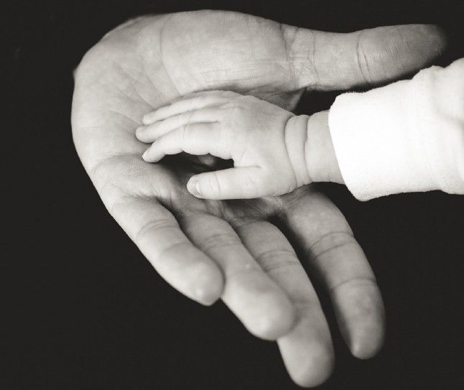
QUESTIONS 2 (Pause after each question.) (Richard McGinnis)
What does your sense of loss tell you about what is very important to you?
When have you yearned for something so much that you were willing to risk failure, not even holding something back to protect yourself?
Recall a time when you were vulnerable with someone – or with God.
COMMUNAL SILENCE (Bill: Share slide with questions, time 2:00, chime.)

READING 3 – Intro and “We Shall Overcome” by Nimo Patel & Daniel Nahmod (Bill)
Holding images of total vulnerability, we turn our attention to the 40 passengers and crew on United flight 93 that went down in a field near Shanksville, PA 21 years ago today. In the 35 minutes after the flight was taken over, they got information from the ground, came up with a plan, voted, prayed, acted, and fought. They revealed true heroism, and are remembered for their sacrifice, and honor.
(Bill ) Play https://www.youtube.com/watch?v=S6FN0EmK87c (First 3 minutes)
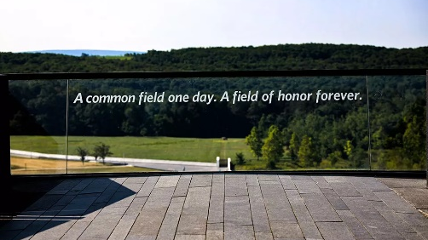
QUESTIONS 3 (Pause after each question.) (Richard McGinnis)
The passengers of Flight 93 overcame their fear and acted out of self-giving love. Sit with them and hold their last minutes inside yourself.
What walls hold you in? How do feel about those walls – perhaps grateful?
COMMUNAL SILENCE (Bill: Share slide with questions, time 2:00, chime.)

Anne Regan: Kathy Cavanaugh will lead us in sharing our personal reflections.
SHARING (Kathleen Cavanaugh)

We know the wisdom of our community includes both words shared and silent listening. Now, if you’d like, we invite you to share the essence of what is emerging within you from our readings and silence. Let’s begin in silence as we gather our reflections. [Long-ish pause]

Who would like to start our sharing? Remember to unmute yourself to speak and mute yourself again afterwards.

[Sharing]

[Long silences are common and they can be fruitful. If there is extended silence after 15 minutes:] Is there anyone else who would like to share? [Long pause]

[Stop by about 11:20.]

Thank you. Let us pause for a minute of silence to hold all that has been said, and to notice what is rising in us in response. (Long pause)

Hold onto what God is saying in you right now. We can continue after the final song, as we often do. For now, let us respond to God in prayer.

OFFERTORY (Bill Cavanaugh)
(Bill) Play: Last minute of Nimo Feat’s “We shall overcome.”
https://youtu.be/S6FN0EmK87c?t=271
What can you do this week to participate in God’s plan and help Love lead the way?
(Long pause)
Holy One, thank you for opportunities like these when we can be your presence. May it be so.
PRAYERS OF THE COMMUNITY (Anne Regan/Bill Fanelli)
Let’s pause to notice the prayers that arise in us now. (Pause) Our response will be: Holy One, keep our hearts open.
Let us hold in reverence those who give of themselves, even to the full measure of their lives, like the September 11 heroes on flight 93 and like refugees all over the world seeking safety for their loved ones. For this we pray. Holy One, keep our hearts open.
Let us hold in reverence people who are suffering grief and loss right now. May we stand in solidarity as the world did on September 11. For this we pray. Holy One, keep our hearts open.
Let us hold in reverence those who pour themselves out in relationship, in prayer, and in service in order to bend the arc of history toward love and toward justice. We join with women religious in seeking to BE your presence in the world. For this we pray. Holy One, keep our hearts open.
Let us hold in reverence relatives, teachers, medical staff, and others who risk themselves in order to care for vulnerable children, including our adult children. For this we pray. Holy One, keep our hearts open.
For what else shall we pray? Please unmute yourself to speak, and mute yourself afterwards.
[Shared prayers] Holy One, keep our hearts open.

O You who know us better than we know ourselves, thank you for walking with us in our vulnerability. We keep our hearts open with confident faith that whatever comes will always hold the gift of your Spirit. With gratitude, we welcome the Spirit you share. We entrust all to you. Amen.

CELEBRATION OF COMMUNION (Sister Grace Hartzog)

O Great Love, we are humbled and emboldened
to know that you trust us to be your body in this world.
We are part of that body as we let go of all that separates us from you,
and as we embrace one another and your entire creation with merciful love.

We remember the night before Jesus died.
At dinner with friends, Jesus knew all that would soon be asked of them,
and, loving them to the end, Jesus showed them how to care for each other
as they went out into the world.
First Jesus washed their feet
and said, “… as I have done for you, you should also do.”
Then he looked at what was in front of them, the bread and the wine,
gifts of Earth and the work of human hands, and blessed them.
So let us, too, invite God right now into what is front and center in our lives
knowing that God will indeed enter what we offer – and bless it. [Pause.]

Holy One, we entrust ourselves to you and to one another.
Make us your bread of abundance. Make us your wine of joy.
Let even our fragments be plenty to share.
Amen.

To extend our communion, Norb Bufka will lead us in the prayer of Jesus.

THE PRAYER OF JESUS (Norb Bufka)

Now let us join our hearts in harmony with our family throughout the world:
All (muted): Our Father, Our Mother, who unite heaven and earth, holy is your name.
Your kingdom come. Your will be done on earth as it is in heaven.
Give us this day our living bread
and forgive us our trespasses as we forgive those who trespass against us,
and do not let us fall into temptation, but deliver us from evil
for the kingdom, the power, and the glory are yours, now and forever. Amen.

FINAL BLESSING (Kathy Heller)

Brené Brown writes, “Faith is a place of mystery, where we find the courage to believe in what we cannot see and the strength to let go of our fear of uncertainty.”

Let us take a deep breath to open ourselves to the blessing of this mystery. (deep breath)

In gratitude, we feel the miracle that
our beloved God chooses to be vulnerability to us,
endlessly pouring out blessings
in hope that we will open ourselves to receive them.
It is in our vulnerability that God’s blessings come to life –
love, belonging, joy,
courage, empathy, creativity,
hope, empathy,
accountability, authenticity, and strength.
Vulnerable and blessed,
we unite with the Love that shall indeed overcome.

[Pause.]
Feeling that blessing, let’s join Linda Donaldson in singing the African-American spiritual, “Over My Head, I Hear Music in the Air.”

CLOSING: Over My Head, I Hear Music in the Air (Linda Donaldson)
Refrain:
Over my head I hear music in the air.
Over my head I hear music in the air.
Over my head I hear music in the air;
There must be a God somewhere!
1. Oh, when the world is silent,
I hear music in the air;
oh, when the world is silent,
I hear music in the air;
oh, when the world is silent,
I hear music in the air;
there must be a God somewhere. [Refrain]
2. And when I'm feeling lonely,
I hear music in the air;
and when I'm feeling lonely,
I hear music in the air;
and when I'm feeling lonely,
I hear music in the air;
there must be a God somewhere. [Refrain]
3. Now when I think on Jesus,
I hear music in the air;
now when I think on Jesus,
I hear music in the air;
now when I think on Jesus,
I hear music in the air;
there must be a God somewhere. [Refrain]

RESOURCES:
Reading 2: “Returning to Our Original Love: The Grace of Vulnerability” by Sister Miriam D. Ukeritis, in the Summer 2022 Occasional Papers of the Leadership Conference of Women Religious (LCWR).

Final blessing derived from Brené Brown’s words: “Vulnerability is the birthplace of love, belonging, joy, courage, empathy, and creativity. It is the source of hope, empathy, accountability, and authenticity. If we want greater clarity in our purpose or deeper and more meaningful spiritual lives, vulnerability is the path.”

