Solidarity with Sisters Communal Prayer, November 21, 2021
34th Sunday in Ordinary Time

The King of Glory

HELLOs and then Betty mutes everyone. (Betty Thompson)

WELCOME (Betty )
Welcome, everyone!
- Introductions – people who haven’t been here before?
- Thanks to Mary Ott who prepared this communal prayer.
- Thanks to the people who will be reading and leading us in prayer and song today:
Reggie Ott, Bill Fanelli, Anne Regan, Richard McGinnis, Peggy Thompson, Judy Sholes, Maryann Dolan, George Urban, and Alicia Urban.
- Thanks for sharing names of your loved ones and to Terri Butel for creating a way for us to share our communion with them today.

SETTLING IN (Betty)
Let your breath bring you into quiet so you can be attentive to each other and to the Spirit. Notice your breath as it goes in and out…. Let it slow and deepen… and slowly fill you with the peace of Christ. We begin with 3 deep breaths. One to be here… one to be together… and one to know the Spirit who never leaves us.

GREETING / CALL TO WORSHIP (Mary Ott)

Beloved Community, rejoice! The Spirit of Christ is alive in us! Alleluia! Alleluia!
All: Thanks be to God! Alleluia! Alleluia!

Now Reggie Ott will lead us into our celebration with the song “The King of Glory.”

OPENING SONG: “The King of Glory” (Reggie Ott)
by Fr. Willard F. Jabusch (Copyright: Jabusch, administered by OCP Publications).

Refrain:
The King of glory comes, the nation rejoices.
Open the gates before him, lift up your voices.
Verse 1:
Who is the King of glory, how shall we call him?
He is Emmanuel, the promised of ages.
(Refrain)
Verse 2:
In all of Galilee, in city or village,
He goes among his people curing their illness.
(Refrain)
Verse 3:
Sing then of David’s Son, our Savior and brother;
In all of Galilee was never another.
(Refrain)
Verse 4:
He gave his life for us, the pledge of salvation,
He took up on himself the sins of the nation.
(Refrain)
Verse 5:
He conquered sin and death; he truly has risen.
And he will share with us his heavenly vision.
(Refrain)

(Pause)

INTRODUCTION TO THEME With quotations from Catholic Women Preach (Mary Ott)

The theme of this week’s readings is the kingship of Jesus as foretold by Daniel in the Old Testament. As Americans we may recoil at the idea of a king—after all our War of Independence was fought to free the colonies from the English king. We also might bristle at the male focus. Putting aside our reactions to the language, what is it that we are hearing in these readings?

The role of Jesus’s kingship, as first described by Daniel, was not political for Jesus was not a king in the way the world normally thinks of one.
“… Jesus says ‘behold, the kingdom of God is among you.’ God’s reign is not only something that we look forward to at the end of time, nor is it simply a realm that we will someday reach. It is also something that we can experience here and now even if only in glimpses…. [We enact the kingdom] whenever we love our neighbor, give of ourselves to honor their dignity, or put ourselves on the line for their sake….”
Jesus ushers in an everlasting kingdom that includes all of us. “Our task is to look for the hints of the kingdom that are already present in our world. We might find it in places we’d least expect. “
Today we start with a reading from Daniel, followed by a short reading from the Book of
Revelation.
(Slight pause)

(Mary Ott) Bill Fanelli will read from Daniel and then from the Book of Revelation.
Then Anne Regan will offer questions and silence for reflection.
Feel free to stay with whatever question calls you.

READING 1a: Daniel 7:13-14 (Bill Fanelli)
As the visions during the night continued, I saw one like a Son of man coming, on the clouds of heaven;
when he reached the Ancient One and was presented before him,
the one like a Son of man received dominion, glory, and kingship; all peoples, nations, and languages serve him. His dominion is an everlasting dominion that shall not be taken away,
his kingship shall not be destroyed. (Slight pause)

READING 1b: Book of Revelation 1:5-6 (Bill Fanelli)
Jesus Christ is the faithful witness,
the firstborn of the dead and ruler of the kings of the earth.
To him who loves us and has freed us from our sins by his blood, who has made us into a kingdom, priests for his God and Father, to him be glory and power forever and ever. Amen.
(Slight pause)

QUESTIONS 1 (Pause after each question.) (Anne Regan & Betty- Slide 1)
We hear of both dominion and liberation in these readings. How do these images change your vision of Christ the King?
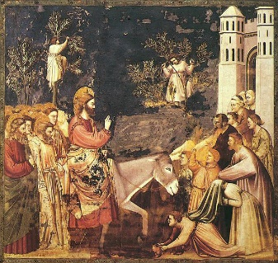
What does it mean to you to be part of Christ’s kingdom?
Slide 1: Jesus enters Jerusalem on Palm Sunday (Giotto)
COMMUNAL SILENCE (Betty: Share slide 2, time 2:00, chime, stop slide.)

(Mary Ott) Now Richard McGinnis will read from the Gospel of John, followed by questions.

READING 2: Gospel of John, 18:33b-37 (Richard McGinnis)
Pilate said to Jesus, "Are you the King of the Jews?"
Jesus answered, "Do you say this on your own
or have others told you about me?"
Pilate answered, "I am not a Jew, am I?
Your own nation and the chief priests handed you over to me. What have you done?"
Jesus answered, "My kingdom does not belong to this world. If my kingdom did belong to this world,
my attendants would be fighting
to keep me from being handed over to the Jews.
But as it is, my kingdom is not here."
So Pilate said to him, "Then you are a king?"
Jesus answered, "You say I am a king.
For this I was born and for this I came into the world,
to testify to the truth.
Everyone who belongs to the truth listens to my voice." (Slight pause)

QUESTIONS 2 (Pause after each question.) (Anne Regan & Betty-Slide 3)
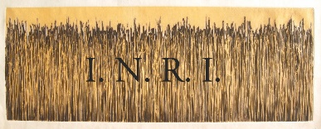
Slide 3: I.N.R.I.
Pilate ordered an inscription on the cross “Jesus the Nazarean, the King of the Jews.” What might you have thought if you had seen this inscription—what sort of king could this be?
Is Jesus your king, or have you chosen others?
COMMUNAL SILENCE (Betty: Share slide 4, time 2:00, chime, stop slide.)

READING 3: The Book of Remembrance (prepared and shared by Terri Butel)

(Mary Ott) Now we will see our Book of Remembrance, followed by questions.

QUESTIONS 3 (Pause after each question.) (Anne Regan & Betty-Slide 3)
How do you imagine your Loved Ones experiencing the Kingship of Christ?
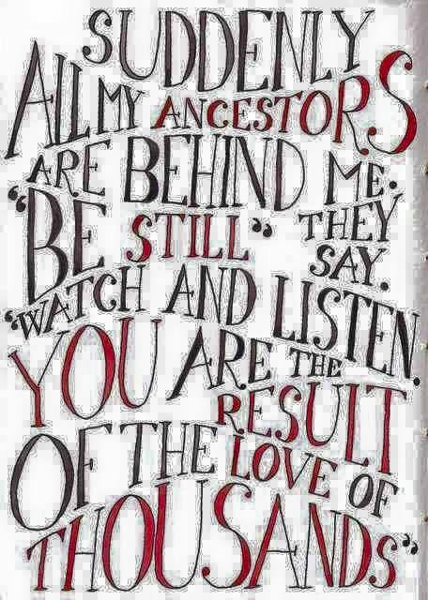
How do you receive support from your beloved ones in eternal life?

Slide 5: Communion of Saints

COMMUNAL SILENCE (Betty: Share slide 6, time 2:00, chime, stop slide.)

(Mary Ott) Peggy Thompson will now lead our sharing.

SHARING (Peggy Thompson)

We invite you to briefly share what emerged in your heart this morning as you listened and as you reflected on these readings. That helps us to glimpse the many ways God is among us. We welcome new voices, and we also know that the wisdom of this community includes both words shared and silent listening,

Let’s remember to leave a bridge of silence between speakers.
Now we begin in silence as we gather our reflections. (Long pause.)

Who would like to begin our sharing? Please unmute yourself to speak.

(Sharing)

Thank you. We have to stop now, and we can continue after the final song, as we often do.

Now Judy Sholes will lead us in prayer.

PRAYERS OF THE COMMUNITY (Judy Sholes)

Reflect on all that has been shared this morning, and notice what prayer is rising in you. (Long-ish pause) Our response will be, “Holy One, hear our prayer.”

King of Peace, bless the leaders and citizens of the earth’s communities. “For this we pray.” “Holy One, hear our prayer.”

King of Leaders, guide the Leadership Conference of Women Religious in its work with the religious communities of women. “For this we pray.” “Holy One, hear our prayer.”

King of Consolation, bless those who mourn. “For this we pray.” “Holy One, hear our prayer.”

King of all People, bless members of the LGBTQ community, particularly transgender persons. “For this we pray.” “Holy One, hear our prayer.”

King of the Earth, guide those who are seeking to rein in global climate change.
“For this we pray.” “Holy One, hear our prayer.”

Now, for what else shall we pray? Please remember to unmute yourself and end your prayer with “For this we pray.” Who would like to begin?

(People speak.) “Holy One, hear our prayer.”

O God, we give you all our prayers, spoken and unspoken. We will do all that we can to put our prayers into action – while entrusting the outcome to you.
(Slight pause)

OFFERTORY (Maryann Dolan)
We celebrate the amazing fact that the Holy One is with us and lives in us now and at every moment. We offer ourselves to God in gratitude for having been chosen, just as we are, to be God’s Living Sign in our world. What special call will I live out during the coming week? (Pause.)

Let us pray: Generous God, Creative Spirit, we accept our responsibility in the communion of saints. We commit to share our time, our talents and our treasures so that we may be a light and a witness to the transforming love of Jesus the Christ.

CELEBRATION OF COMMUNION (George Urban)
O Great Love, we are humbled and emboldened
to know that you trust us to be your body in this world.
We are part of that body as we let go of all that separates us from you,
and as we embrace one another and your entire creation with merciful love.
We give you thanks for your presence in and among us. [Pause.]
We remember the night before Jesus died.
At dinner with friends, Jesus knew all that would soon be asked of them,
and, loving them to the end, Jesus showed them how to care for each other
as they went out into the world.
First Jesus washed their feet
and said, “… Do THIS in memory of me.”
Then he looked at what was in front of them, the bread and the wine,
gifts of Earth, and the work of human hands, and blessed them.
So let us, too, invite God right now into what is front and center in our lives
knowing that God will indeed enter what we offer – and bless it. (Pause.)

Let us invite God into ourselves so that we become God’s living presence in our world. Holy One, you transform us as you nourish us here. May we nourish others as you nourish us.

OUR FATHER, OUR MOTHER (Alicia Urban)

Now let us join our hearts to pray with all who seek peace and justice throughout the world, in the words of the Polynesian and Maori people and the New Zealand Anglican community:

Eternal Spirit,
Earth-maker, Pain-bearer, Life-giver,
Source of all that is and that shall be,
Mother and Father of us all,
Loving God, in whom is heaven:
The hallowing of your name echo through the universe;
The way of your justice be followed by the peoples of the world;
Your heavenly will be done by all created beings;
Your commonwealth of peace and freedom
sustain our hope and come on earth.
With the bread we need for today, feed us.
In the hurts we absorb from one another, forgive us.
In times of temptation and test, strengthen us.
From trial too great to endure, spare us.
From the grip of all that is evil, free us.
For you reign in the glory of the power that is love,
now and forever. Amen.
FINAL BLESSING (Mary Ott)

Filled with the presence of God, may we grow God’s kingdom and offer communion and kindness to a hungry world. Amen.

Now Reggie Ott will lead us in singing “Soon and Very Soon”

CLOSING SONG: “Soon and Very Soon” (Reggie Ott)
by Andrae Crouch (Copyright: Crouch Music Corp., administered by Capitol CMG Publishing)

Verse 1:
Soon and very soon
We are going to see the King
Soon and very soon
We are going to see the King
Soon and very soon
We are going to see the King
Hallelujah hallelujah
We're going to see the King
Verse 2:
No more crying there
We are going to see the King
No more crying there
We are going to see the King
No more crying there
We are going to see the King
Hallelujah hallelujah
We're going to see the King
Verse 3:
No more dying there
We are going to see the King
No more dying there
We are going to see the King
No more dying there
We are going to see the King
Hallelujah hallelujah
We're going to see the King
Repeat Verse 1:
Soon and very soon
We are going to see the King
Soon and very soon
We are going to see the King
Soon and very soon
We are going to see the King
Hallelujah hallelujah
We're going to see the King

RESOURCES
Theme: Jordan Denari Duffner, “Solemnity of Christ the King: November 21, 2021,” www.catholicwomenpreach.org/preaching/11212021
Slides 1 and 2: Giotto-Scrovegni—26--Entry into Jerusalem2.jpg [fresco by Giotto in Scrovegni Chapel]
Slides 3 and 4: “I.N.R.I.” printed on “Wide Grass” [etching by Mary D. Ott, 2009]
“The Book of Remembrance” by Terri Butel
Slide 5 and 6: A quote from author Linda Hogan,
https://globalworship.tumblr.com/post/119142509690/the-communion-of-saints-art

