Solidarity with Sisters Communal Prayer for February 21, 2021
First Sunday of Lent

“Whoever practices the truth comes to the light.” John 3:21

CHECK-IN and then Betty mutes everyone. (Suzie De Quattro and Betty Thompson)

WELCOME (Betty Thompson)
Welcome, everyone!
- Introductions – people who haven’t been here before?
- Lynn and Norb Bufka prepared today’s communal prayer.
- Thanks to Reggie Ott, Stu Sklamm, Linda Donaldson, Pat Campbell and Marilyn Voigt for leading our music.
- Thanks to the people who will be reading and leading us in prayer today: Joan Sklamm, Greg Campbell, George Fulk, Jeff Wells, Debbie Ballard, Jim DeQuattro, Kathy Linaberry, Suzie DeQuattro, Richard McGinnis, Betty Thompson, Maryann Dolan.
- If you’d like to read on future Sundays, please put a note in Chat or email later.

SETTLING IN (Betty Thompson)

We are not all in the same place, but we can still be together by sharing a common breath. So let us begin by slowly taking one collective breath together - in and out. With each breath let the Spirit of God settle deeper into you. Let your breath carry away tensions from your body and distractions from your mind. In and out. Now let’s take 3 more breaths. One to be here…one to be together…and one to make space for the light of God in you.

OPENING RITUAL (Lynn Bufka and Linda Donaldson)

Lynn: Beloved Community, Lent is the call to move from darkness to light.
All: O God, we hear you calling.
Lynn: Beloved Community, we begin just where we are.
All: O God, we hear you calling.
Lynn: Lord, you have the words of everlasting light.
All: O God, we hear you calling.
Linda (and all, muted): “Change our hearts (this time)” by Rory Cooney
[How it sounds: https://www.youtube.com/watch?v=5xGdAxcLcJU]
Change our hearts this time,
You word says it can be.
Change our minds this time
Your life could make us free.
We are the people your call set apart,
Lord, this time change our hearts.
Lynn: “Lent is a call to weep for what we could have been and are not. Lent is the grace to grieve for what we should have done and did not. Lent is the opportunity to change what we ought to change but have not. Lent is not about penance. Lent is about becoming, doing and changing whatever it is that is blocking the fullness of life in us right now.” (Joan Chittister, OSB)

(Betty: Start slide during last sentence above.)
Lynn: Let’s pause and reflect on what is hindering the light in us right now. [Pause]

Lynn: Let us pray together:
All (muted):
I know I have often sinned in my thoughts and in my words, in what I have done and what I have failed to do.
I place my trust in your mercy, O God. And I ask that you, my sisters and brothers, pray for me as I seek to be light. Amen. (Betty: Stop slide.)

Linda (and all, muted):
Change our hearts this time,
You word says it can be.
Change our minds this time
Your life could make us free.
We are the people your call set apart,
Lord, this time change our hearts.

CALL TO WORSHIP / GATHERING PRAYER (George Fulk)

God of the desert, God of the mountaintop, God of all captives, we are here to walk in your light and to carry your freedom to the world. May we inquire, nudge, and challenge each other to recognize what is ours to do.
Amen. [Brief pause]

Lynn will now introduce us to today’s theme.

INTRODUCTION TO THEME (Lynn Bufka]

How we understand and celebrate our sacraments has changed in the history of our Church. The most recent changes occurred with Vatican II although these changes have been slow to penetrate universal Catholic consciousness. Now, the Sacrament of Reconciliation is no longer simply confessing a list of sins and receiving a penance of Our Fathers and Hail Marys, but is an acknowledgement and an embrace of God’s mercy and forgiveness. It helps us transform our sin into an act of transformation of ourselves through God’s mercy.
Lent is a traditional time to celebrate this sacrament because of the focus on self-reflection. It fits nicely with our Lenten theme of Darkness to Light. The darkness in all of our lives, called sinfulness, is transformed into brightness through our reflection and God’s loving mercy.
Sinfulness, or sin, is not just a break in a personal relationship but it can also be a rupture in one of the many communities we are part of. Our sin also is complicit with the sins of racism, sexism, and other social and cultural systems. The darkness is present and interacts with everyone and everything around us.
Our prayer Ash Wednesday reminded us that during these 40 days of Lent we seek God and, in doing so, to banish the fear, despair and anger that get in the way of our living deeply this new life in God. And so let us each ask ourselves, What hinders me from coming home to God? This Lent, how do you hope to change your mindset and your heart?
In Genesis, we hear of the covenant God has with us, and not only is it a covenant with people, it is a covenant with all creation. This covenant with all creation reminds us that our actions are connected to our entire world, not just people. In our Gospel reading from Mark, Jesus proclaims the good news and calls people to repent and believe. Our final reading and our own reflections will help us find some possible answers to what it means to repent and believe.
(Slight pause)

As we enter into our readings, Marilyn Voigt will lead us in song:

ENTRY INTO READINGS (Marilyn Voigt)

Marilyn sings (and all, muted): [The music is at the end of this file.]
Lead us from darkness into light. Lead us from darkness into light.
Lead us from darkness, lead us from darkness,
Lead us from darkness into light.

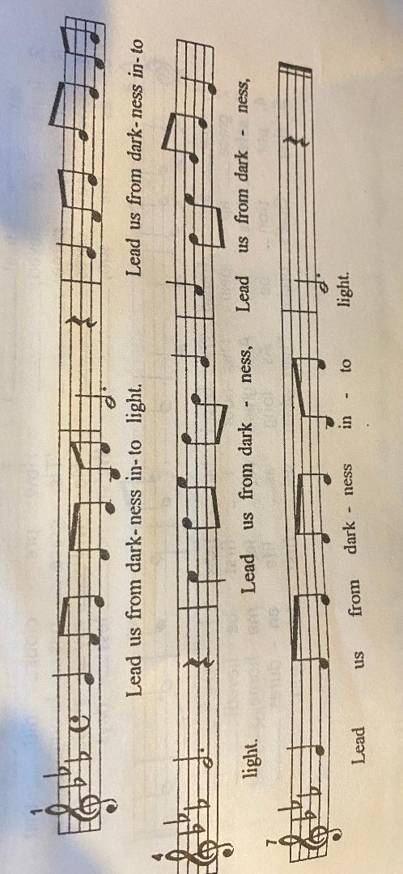

Lynn: Jeff Wells will read from the book of Genesis Chapter 18, followed by questions and silence for reflection. Feel free to stay with whatever question calls you.

READING 1 (Jeff Wells)

God said to Noah and to his sons with him:
“See, I am now establishing my covenant with you
and your descendants after you
and with every living creature that was with you:
all the birds, and the various tame and wild animals
that were with you and came out of the ark.
I will establish my covenant with you,
that never again shall all bodily creatures be destroyed
by the waters of a flood. … I set my bow in the clouds to serve as a sign
of the covenant between me and the earth.

[Slight pause]

REFLECTION QUESTIONS (Jim DeQuattro)

God’s covenant is a mutual agreement between God, us and all of creation. How do you live out your part in this covenant?

What is your role in transforming the brokenness caused by a breach in the covenant?
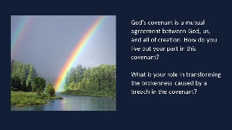
SILENT REFLECTION (Betty: Slide 2, time 2:00, chime, stop slide)

Lynn: Next, Debbie Ballard will read to us from Mark 1:12-15

READING 2 (Debbie Ballard)

The Spirit drove Jesus out into the desert,
and he remained in the desert for forty days,
tempted by Satan.
He was among wild beasts,
and the angels ministered to him.
After John had been arrested,
Jesus came to Galilee proclaiming the gospel of God:
“This is the time of fulfillment.
The kingdom of God is at hand.
Repent, and believe in the gospel.”

[Slight pause]

REFLECTION QUESTIONS (Jim DeQuattro)
Reflect on the occasions or situations that tempt you to sin, and how do you deal with that?
How does believing the good news help you uphold your part of the covenant? How do your communities know you believe?
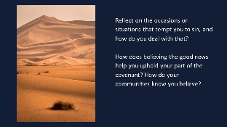
SILENT REFLECTION (Betty: Slide, time 2:00, chime, stop slide)

Lynn: Now Mary (Candy) Fernandes will read an edited excerpt from a commentary by Patricia Datchuck Sánchez.

READING 3 (Mary Candy Fernandes)
For the better part of my life, I have looked at Lent as an invitation to recognize my failures and sinfulness, to seek forgiveness and to form a new resolve in order to grow deeper in faith, more fervent in love and firmer in hope.
Admittedly, this personal experience of Lent is necessary and important, however, if I look only within myself, my focus becomes too narrow, my horizons too limited, my ideals too provincial.
Through the readings, signs and bywords which characterize the Lenten respite, the church challenges each believer to turn his/her gaze away from self in order to look at God.
Isn’t this shift in perspective precisely what is meant by repentance? To turn to God, to focus and to center on God is at the very heart of the experience of conversion. But Lent is not merely a time for making a change in my direction, or my mind and my heart; this is a season for putting on the mind and heart of God which has been made known to us in Jesus.
In illustration of the shift of focus toward which Lent prompts us, I would offer one of the works of the painter William Zdinak. Zdinak was commissioned to produce a picture for a religious art show. For weeks he stared at the empty canvas, haunted by the words of Thomas Merton who said, “If there were no other proof of the infinite patience of God with men, a very good one could be found in God’s toleration of the pictures that are painted. . . under the pretext of being in God’s honor.”
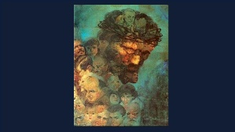
With a prayer to the God of patience, Zdinak turned his attention away from himself toward God and began to paint. When he finished, he had created a likeness of Christ in ruddy skin tones, with kind eyes and handsome Mediterranean features. While his work was well done, it was not unlike so many others which were hung on display for the art show. However, when viewers drew nearer to the painting, they were surprised to find that Christ’s head was actually a composite of scores of smaller faces. Represented were men, women and children of every ethnic background, of all races and walks of life. Included among the myriad faces were notables like Mahatma Gandhi, Martin Luther King, Abraham Lincoln, and John Kennedy. When viewers drew back from the painting, the mosaic of human faces blended once again to reflect the image of Christ.
[Slight pause] (Betty: Start slide mid-paragraph, end slide after paragrph.)

REFLECTION QUESTIONS (Jim DeQuattro)

What is your sinfulness, and how does it turn you from God and harm the community?

Imagine the image of a personal enemy or someone you dislike in the painting. How does this affect seeing Jesus in all people?

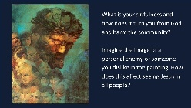
SILENT REFLECTION (Betty: Slide, time 2:00, chime, stop slide)
Slide of the painting described above
SHARING TIME (Richard McGinness)

We invite you to briefly share what emerged in your heart this morning as you have reflected upon our reading and music. We welcome everyone who wants to speak, and we also know that the wisdom of this community includes both words shared and silent listening.

So let’s begin in silence as we gather our reflections. [Long-ish pause]

Now who would like to start our sharing? Remember to unmute yourself to speak and mute yourself again afterwards.

[Sharing]

[If there is silence more than about 30 seconds before anyone speaks:] Take whatever quiet you need before you speak.

[If there is extended silence during the sharing:] Is there anyone else who would like to share? [Pause.]

[Stop by about 11:22.]

Thank you.

Now Greg and Pat Campbell will lead us in prayer.
PRAYERS OF THE COMMUNITY (Greg and Pat Campbell)
We have just listened to God’s word – in scripture, in everyone’s reflections, and in our hearts and minds. Let’s pause in silence to notice what prayer rises in us now. [Pause….]

Our response today will be:
Singer: Hold us in your mercy.
Singer (and all, muted): Hold us in your mercy.
How it sounds: https://www.youtube.com/watch?v=r1GKnLS1lFA]

After each prayer:
Leader (and all, muted) sing: Hold us in your mercy. (one time)

Let us pray that the Biden administration inspire all with a new vision for the soul of America, For this we pray. (Sung response) Hold us in your mercy.

We pray that LCWR continues to be a beacon of the Gospel in our troubled country. For this we pray. (Sung response) Hold us in your mercy.

May this Black History Month challenge us to recognize the sins of systemic racism in our communities, to understand our contributions and find ways to heal and reconcile. For this we pray. (Sung response) Hold us in your mercy.

We pray in gratitude for the many people who have worked so hard to provide care, comfort and healing to the people of their communities during this pandemic. May they feel supported and strengthened. For this we pray. (Sung response) Hold us in your mercy.

May the Gospel infuse us with a new understanding of the Covenant God made with the Hebrew people and all of creation. For this we pray. (Sung response) Hold us in your mercy.

For what else shall we pray? Please unmute yourself to speak, and mute yourself afterwards.

(Shared prayers)

O Great Love, we place all of our prayers, those spoken and those unspoken, into your care, and we entrust the outcome to you. Amen.
Leader sings: Hold us in your mercy.
Leader (and all, muted): Hold us in your mercy.

OFFERTORY (Joan and Stu Sklamm)
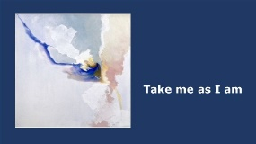
Joan: Loving God, each week we have been offering to you our intent to take a specific action. Week by week, we commit and recommit. Our commitments evolve as we let in more and more light. In musical meditation, we ask you, Holy One: how are we – how am I – to bring your light into the week ahead?
Stu plays: “Take Me As I Am” by John Bell
[Repeat as needed for about a minute.)
(Betty: Start slide in Joan’s final sentence.
Stop slide after Stu plays, before Joan speaks.)

Joan: In thanksgiving for the presence and power of Jesus Christ, and in unity with the Holy Spirit, let us pray. God of abundance, we commit to sharing our time, talents, and treasures so we that we may be a light and a witness to the transforming love of Jesus Christ. Amen.

CELEBRATION OF COMMUNION (Kathy Linaberry)

O Great Love, we are humbled and emboldened
to know that you trust us to be your body in this world.
We are part of that body as we let go of all that separates us from you,
and as we embrace one another and your entire creation with merciful love.
We give you thanks for your presence in and among us. [Pause.]

We remember the night before Jesus died.
At dinner with friends, Jesus knew all that would soon be asked of them,
and, loving them to the end, Jesus showed them how to care for each other
as they went out into the world.
First Jesus washed their feet.
Then he looked at what was in front of them, the bread and the cup,
gifts of the earth and work of human hands, and blessed them.
So let us, too, invite God right now into what is front and center in our lives
knowing that God will indeed enter what we offer – and bless it. [Pause.]

Let us invite God into ourselves so that we become God’s living presence in our world. [Pause.]
Holy One, you transform us as you nourish us here.
May we nourish others with your presence.
Amen.

OUR FATHER (Maryann Dolan)

Now let us join our hearts as if we could join our hands to pray in harmony with Christians throughout the world in the words that Jesus gave us:
All (muted): Our Father, who art in heaven, hallowed be thy name.
Your kingdom come. Your will be done on earth as it is in heaven.
Give us this day our daily bread
and forgive us our trespasses as we forgive those who trespass against us,
and do not let us fall into temptation, but deliver us from evil
for the kingdom, the power, and the glory are yours, now and forever. Amen.

Lynn: As Suzie leads us in our final prayer, we will all respond (on mute) with “God’s mercy endures forever.”
FINAL BLESSING: PRAYER OF MERCY (Suzie DeQuattro)
Your mercy is our hope:
All: God's mercy endures forever.

Give us the will to change our lives, and the lives of others,
by charity, good example and prayer.
All: God's mercy endures forever.

Make us a living sign of your mercy for all to see:
people reconciled with you and with each other.
All: God's mercy endures forever.

In this sign of your love, you forgive us our sins:
may it teach us to love others and to forgive their sins against us.
All: God's mercy endures forever.

In your mercy free us from the past and enable us to begin
a new life of holiness.
All: God's mercy endures forever.

CLOSING SONG (Reggie Ott)

Lead Me, Guide Me -- how it sounds, so everyone can listen before Sunday:
https://www.youtube.com/watch?v=PLpB-dE2DHM

Refrain:

Lead me, guide me, along the way
For if you lead me, I cannot stray.
Lord, let me walk, each day with thee.
Lead me, oh Lord, lead me.

V1
I am weak and I need thy strength and power to help me over my weakest hour.
Help me through the darkness thy face to see, Lead me, oh Lord, lead me.

V3
I am lost if you take your hand from me, I am blind without thy Light to see,
Lord, just always let me thy servant be. Lead me, oh Lord, lead me.

Resources

- Opening Ritual – “Lent is a call…” quote from Benedictine Sister Joan Chittister: http://rosemarieberger.com/2011/03/15/joan-chittister-lent-is-a-chance-to-grieve/
- Opening Ritual – image from “Dawn: A Time-Lapse Photography Experiment” by John Davenport: https://www.youtube.com/watch?v=xF49lnywnAE
- Reflection-question slides’ background: Mark Rothko, part of Blue Orange Red 1961
- Offertory image, 1st Sunday: Take me as I am, image “Untitled (metal clouds-4) by Tarini Ahuja” at https://www.saatchiart.com/art/Painting-untitled-metal-clouds-4/312647/3721426/view
- Rainbow image: http://seasonsofgrace.net/god-noah-and-the-flood-taking-back-the-rainbow/#iLightbox[gallery3647]/0
- Desert image: https://www.google.com/search?q=DESERT+IMAGE&client=firefox-b-1-d&tbm=isch&source=iu&ictx=1&fir=HJTFKa4FVGYi3M%252C2hwUc3vDcRPFvM%252C_&vet=1&usg=AI4_-kQU7eIGT_MnN8HsO-t71JQS13xC-Q&sa=X&ved=2ahUKEwiGg_-Mo-PuAhXVFlkFHTYpCQYQ9QF6BAgEEAE&biw=1366&bih=570#imgrc=3Jl1q9VfoYXc6M
- Third reading source: http://www.nationalcatholicreporter.org/sanchez/locked/cycleb/lentb/lent197b.htm
- Painting image https://grandefalcone.wordpress.com/2012/08/18/painting-in-his-image/#jp-carousel-4948

